
General Acids/Bases Bench Right and Left

Standard Operating Procedure
Rev. 2026-01

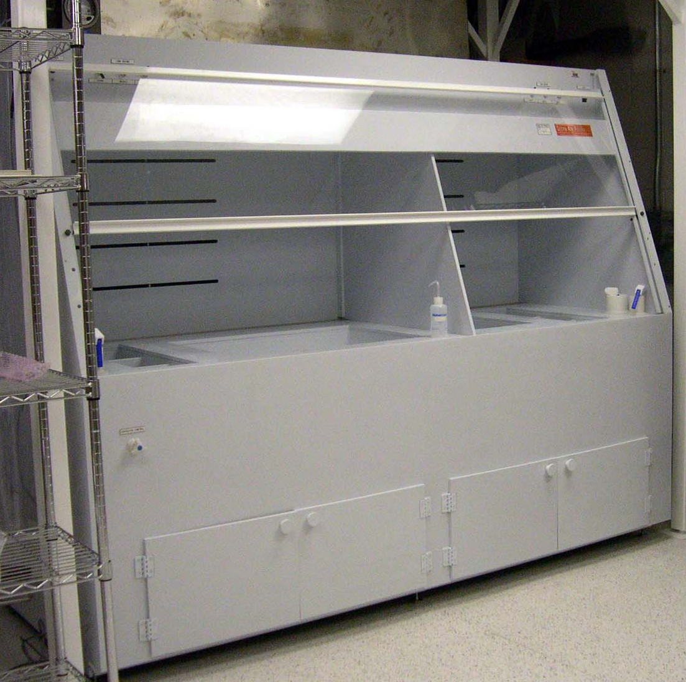

Contents
Bench Features 3
Restrictions 3
Safety 3
Wet Bench Facts 4
Personal Protection Equipment (PPE) 4
NRF Approved Materials and User Material 4
Safe Practice Rules 5
Operation 5
Working safely with hydrogen peroxide mixtures 7
Piranha 7
Waste handling of piranha and solutions with hydrogen peroxide 7

Bench Features
The bench consists of 2 independent sides so that 2 users may use the bench at the same time. The bench is dedicated to general acids and bases. See Table 1.0 below for acceptable chemicals. No other chemicals are allowed without prior NRF staff approval. The bench is equipped with a Nitrogen gun and a DI water spray gun. The large 30” x 20” containment tray in the center of the bench and the 18” x 12” containment tray on the right side are to be used for all acid and base processing and is NOT connected to any drain. The center drain connection is capped off. The three 8”x8” sinks on the far left side are connected directly to city drain. DO NOT POUR ANY CHEMICALS DOWN THESE RINSE SINKS. The storage area under the bench may not be used.

Restrictions

No solvents at this bench. Only chemicals listed in Table 1 are allowed in this bench.
Table 1.0
ACIDS
HF – hydrofluoric acid
BOE – buffered oxide etch
H2SO4 - sulfuric Acid
HNO3 - nitric Acid
H3PO4 - phosphoric Acid
CH3COOH - acetic Acid
HCl – hydrochloric acid
Transene® Etchants (Aluminum A and D, Gold TFA, Nickel TFB, Chrome).
BASES
NH4OH - Ammonium hydroxide
OXIDIZERS
H2O2 – hydrogen peroxide

Safety

- The intent of this SOP is to provide specific information about this bench.
- All UF EH&S Safety practices and procedures must be followed. All wet bench procedures demonstrated during “NRF Safety Training” must also be followed.

Wet Bench Facts

Wet Benches are designed to protect you by providing an enclosed work area that has an air barrier between you and the hazardous materials you work with in the bench.

Working with the sash at the proper level provides protection against inhalation of hazardous vapors, chemical splashes and splatters, fire, or explosion. Do not adjust the sash height of NRF wet benches.

Personal Protection Equipment (PPE)

The following is a list of personal protection equipment required for use of any wet bench when working with acids or bases.
- Full length blue vinyl apron with sleeves. Use the orange belt to secure the apron around your waist. Tie or button the string to secure around your neck
- Long orange chemical resistant gloves
- Full face shield
Wearing the above PPE in areas outside the NRF Wet Processing Bay is not allowed so make sure you have everything you need before donning (putting on) your PPE.

Lack of PPE use is very dangerous and will result in suspension of access to the NRF.

NRF Approved Materials and User Material

    - You may not bring chemicals or substances of any type into the clean room without approval of NRF Staff. All NRF Approved materials will have a MSDS posted at http://nrf.aux.eng.ufl.edu/safety/msds.asp . If the MSDS for the material you would like to use is not listed you may submit a “New material Request Form” found at http://nrf.aux.eng.ufl.edu/safety/default.asp. Click and download the “MS Word” file “New Material Request Form”. Fill out the form and follow instructions on the form.
    - If you need to bring a container of your approved material into the clean room, fill out the Chemical log in/out sheet located in the NRF Gowning Room. NO USER CHEMICALS MAY BE STORED INSIDE YOUR GROUP BASKET.
    - Personal use chemicals/substances that have been approved by NRF Staff may be stored only in the appropriate chemical storage location. NRF Staff will show you where.

Safe Practice Rules

    - No use of red tagged chemicals after hours or on weekends.

    - Do not use computers or telephones while wearing PPE to prevent contamination to other users.

    - The safety shower is located at the end of the bay, know the location of the water ON actuator just in case you need it in a hurry.

    - Chemicals should be placed no closer than 6 inches from the front opening of the wet bench. Placing them closer to the front opening interferes with the airflow and reduces the level of contaminant protection for individuals working at the wet bench.

    - Always keep your chemical beakers inside the double containment area within the wet bench.

    - Place equipment so that it does not block airflow to slots or vents in the baffle plate at the back of the wet bench. When possible, elevate bulky equipment to allow air to flow under the equipment, as well as around and over it.

Operation

    - Before starting any chemical work, be sure to have the following in place:
      - user contact information, date and chemicals in use written on yellow cleanroom paper
      - verify the correct waste bottle is placed inside the wet bench
      - Verify that the waste bottle has enough space to hold your waste chemical
      - For processes that include the use of hydrogen peroxide, read the following sections for “Pirahna” and “Waste handling of solutions that contain Hydrogen Peroxide” before proceeding
      - your samples
      - sample containers
      - proper forceps for sample handling
      - verify you can easily remove your samples from the container before adding liquids
      - wipes
      - Retrieving items during the processing can create accidents and spread contamination.
    - Minimize the quantities of materials that might be involved in a fire or explosion by limiting the amount of chemicals used in the wet bench.
    - Do not lean into the wet bench to work with hazardous chemicals. This negates the protection the wet bench provides against inhalation of hazardous vapors.
    - Do not use the wet bench to evaporate hazardous wastes. This practice is illegal. It violates the Clean Air Act and is punishable by large fines.
    - Do not store chemicals inside a wet bench.
    - Log on to the Wet Bench using the Tumi System before you don (put on) your PPE and before you start work. There is a separate login for left and right sides of the bench and are treated as 2 different tools. While logging in you will be required to check a box for each chemical you intend to use.
    - Place all chemical containers within the larger containment tray. The left bench side tray is 30” x 20” and the right bench side tray is 18” x 12” containment tray (see table 1 above for approved chemicals).
    - When done, pour waste into waste container using the funnel and thoroughly rinse the funnel with DI water and return to rack. Also rinse the waste bottle if you believe there may be chemical on the outside of the bottle. Dry the bottle using clean wipes and return the waste bottle to the proper labeled tray storage location. Used wipes go into the “Acid Solid Waste Can”.
    - Rinse the top bench surfaces and the containment trays using the DI spray gun. To turn on the aspirator, open the aspirator control valve (located lower right side of bench) completely counter clockwise. Place the end of the aspirator tube down into the capped off drain hole in the center of the tray. Wait a few minutes and siphon one more time after all the water has drained to the center of the tray. CLOSE the aspirator valve (fully clockwise) when done aspirating.
    - Thoroughly rinse all used containers, tweezers etc.. using DI water. The front left DI water rinse tank may be used for this purpose.
    - Return all containers to the rack when done and everything is rinsed.
    - Log off the Tumi.

Working safely with hydrogen peroxide mixtures

Piranha

Traditional piranha clean is a 3:1 mixture of sulfuric acid : hydrogen peroxide and is used to remove organics from substrates. Piranha solutions are extremely energetic and may result in injury from chemical or thermal burns if not handled with extreme caution. Please follow the safe handling and disposal procedures below.

• Slowly add the hydrogen peroxide to the sulfuric acid and not the other way around.
• Never add more than 50% (volume) of hydrogen peroxide as it may become explosive.
• Always use glass beakers because the solution attacks many plastics.
• Temperatures can exceed 100°C so never pick up the glass beaker once it is mixed, or your hands can be burned.
• Adding any acids or bases to piranha or spraying it with water will accelerate the reaction. This also includes photoresist, which is a strong base.

Waste handling of piranha and solutions with hydrogen peroxide

• Never add ANY hot solution to a waste bottle. The solution MUST be allowed to cool below 40°C which may take an hour or more depending on the volume used.
• Place a thermometer in the beaker and move it to the cooling area. Properly label with the date, time, chemical names, and your name.
• You may log off the TUMI, but continue to monitor the solution temperature.
• When the temperature is less than 40°C, log back into the bench and pour the solution into the appropriate waste bottle.
• The piranha waste bottle MUST be glass, MUST have a secondary containment jacket (which is also labeled), and MUST have a vented cap. The vented caps are on the waste rack, 3rd shelf from the bottom and have NRF written on them.

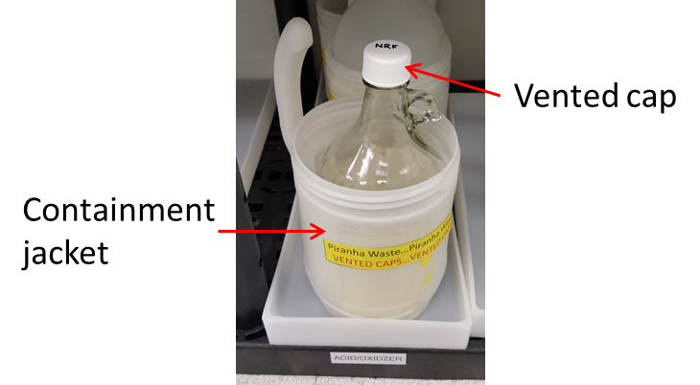
• There will be two other standard waste bottles for oxidizer solutions and these may be stored in poly bottles but also require containment jackets and vented caps;
- SC1 (mix of ammonium hydroxide and hydrogen peroxide)
- SC2 (mix of hydrochloric acid and hydrogen peroxide)
• Disposal of pure hydrogen peroxide, that has been used to etch certain materials, may be disposed of in the SC1 waste.
• If you generate your own mixture that contains hydrogen peroxide, you must contact staff to create a waste bottle for you.
• Do not fill any of these waste bottles past the “Full” mark(see image below). Contact staff when one is full and we will replace. Do not create your own waste bottle for these solutions.

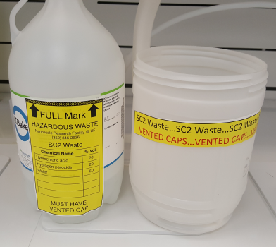
      - To rinse containers, tweezers, etc., place them inside the rinse baths at the ends of the bench and use the DI gun.

