

FPP-5000 4 Point Probe

Standard Operating Procedure Rev. 2026-01

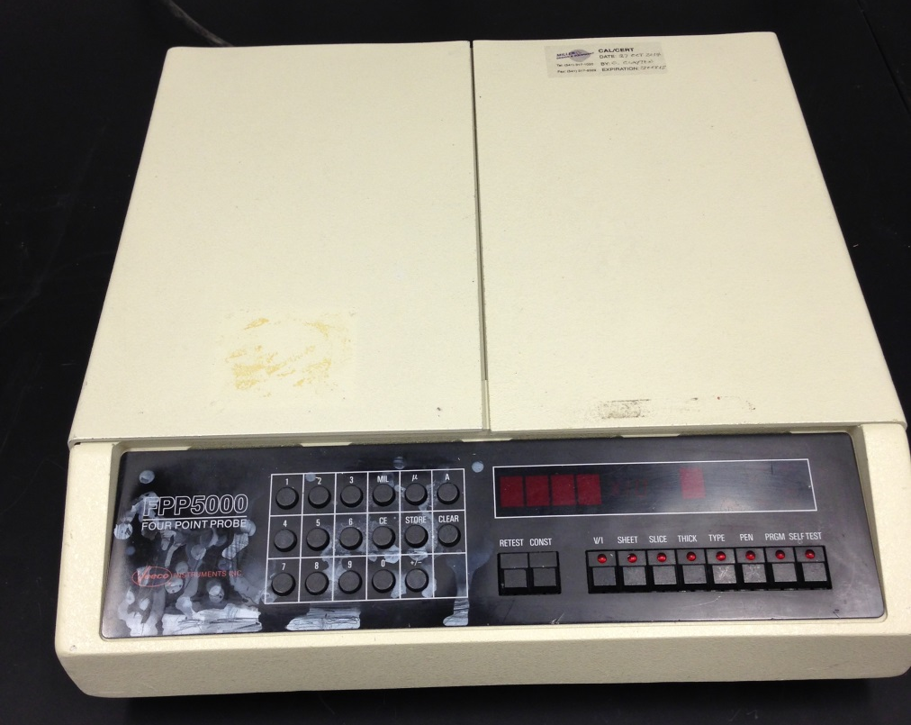

  - Application

The DektakXT system takes measurements by moving a diamond-tipped stylus over the sample surface according to a user-programmed scan length, speed, and stylus force. It can be used to measure step heights, surface roughness, waviness and stress. Vertical resolution is 1Å max, using the 6.55µm range and the stylus force can be varied from 1mg to 15mg. The Dektak XT can accommodate wafers up to 200mm and features a motorized X-Y stage with 3D mapping capability.

  - NRF Contact

David Hays

Table of Contents
1. Safety information 3
2. Prerequisites for use 3
3. Keyboard Description 4
4. Start Up 5
5. Operation 5
5.1. Measurement Using The Lid 5
5.2. Measurement Using The Handheld Probe 7
6. Ending The Session 8
7. Appendix 9
7.1. Programmable Operation 9
7.2. Error Codes 10

- Safety information
    - This machine utilizes HIGH VOLTAGE. Do not touch the probe tips directly.
    - The probe tips can be easily damaged. Press the probes gently.
- Prerequisites for use
- User of the RSC facilities.
- Up-to-date hazardous waste training.
- Training by staff.
- User will be responsible for lost or damaged equipment due to negligence. Negligence means not following the SOP, not asking staff for assistance, intentionally damaging items, etc.
- Keyboard Description
- V/I - Displays measured V/I multiplied by programmed GEOM Constant.
- SHEET - Displays sheet resistance based on measured V/I.
- SLICE - Calculates the bulk resistivity of a slice of layer whose thickness is entered in the PRGM mode.
- THICK - Calculates the thickness of a layer of slices whose bulk resistivity is entered in the PRGM mode.
- TYPE - When selected, a type test is performed.
- PEN - When selected, a penetrate voltage is applied to the sample to breakthrough surface oxides prior to measurement.
- PRGM - Put the keyboard into the PRGM mode for entering bulk resistivity or film thickness. Press STORE afterwards to store the input into system memory.
- SELF-TEST - Performs a system self-test.
- RETEST - Performs a retest when the previous test failed.
- CONST - Displays the selected input stored in the memory.
- NUMERICAL KEYS - To enter the input required for calculation.

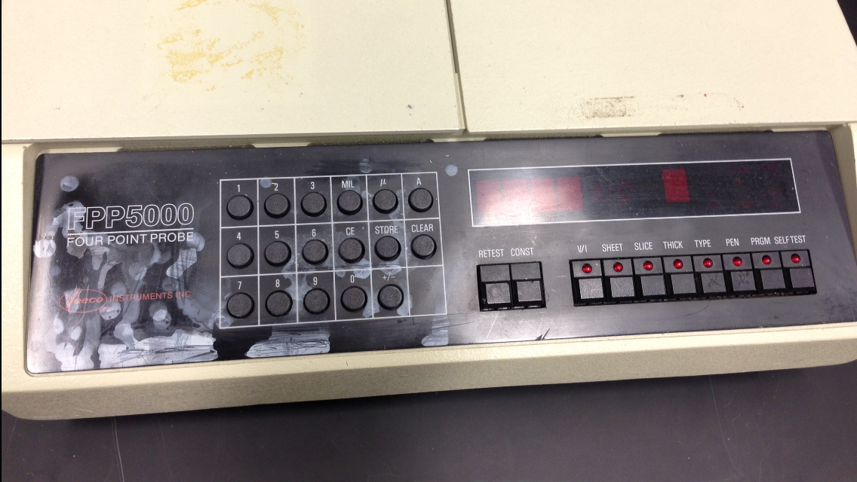
- Start Up
    - Check out handheld probe at front desk, if needed.
    - Login to TUMI.
- Operation
  - Measurement Using The Lid
    - All display lights should be on except FAIL.

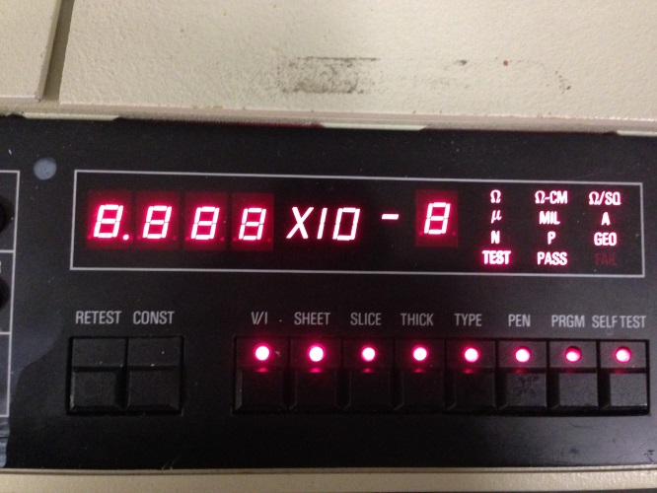
    - Press CLEAR

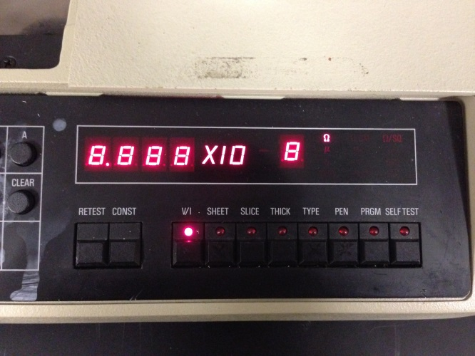

    - Open the lid and place wafer holder (2” or 4”) inside of machine. The wafer holder MUST be used in this instrument.
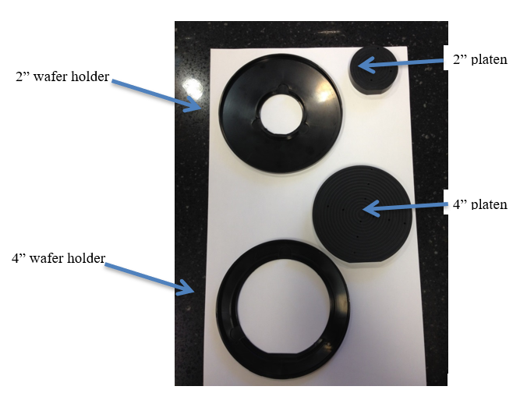
CAUTION  CAUTION
Loading samples without the use of the wafer holder will damage
the probe tips and lead to a costly repair.

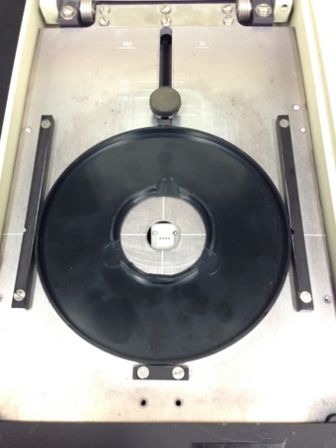

    - Place the wafer (shiny side down) you wish to probe in the appropriately sized wafer holder (2” or 4”).
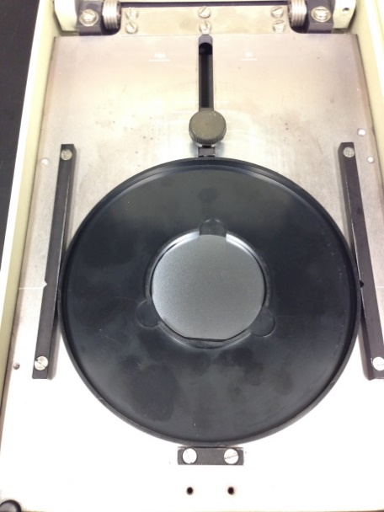
    - Place platen (spiral side down) on top of wafer.
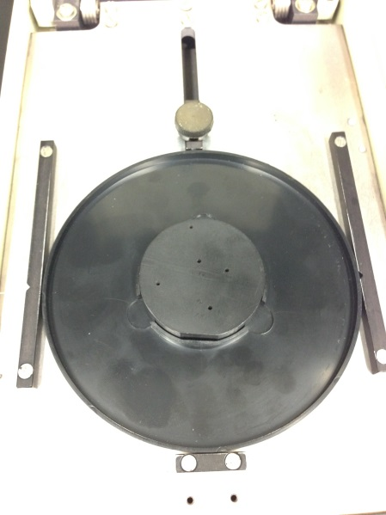
    - Select desired measurement mode.
      - Typically, this will just be SHEET and possibly TYPE
    - Close the lid and gently press down until the measurement is complete. Results will be shown on the display.
    - When finished open the lid, remove your wafer and the holders, and then close lid.
  - Measurement Using The Handheld Probe
    - The handheld probe can be used as an alternate to the main console probe, but not at the same time.
    - Connect to the port below the ON/OFF switch on the left rear of the main console.
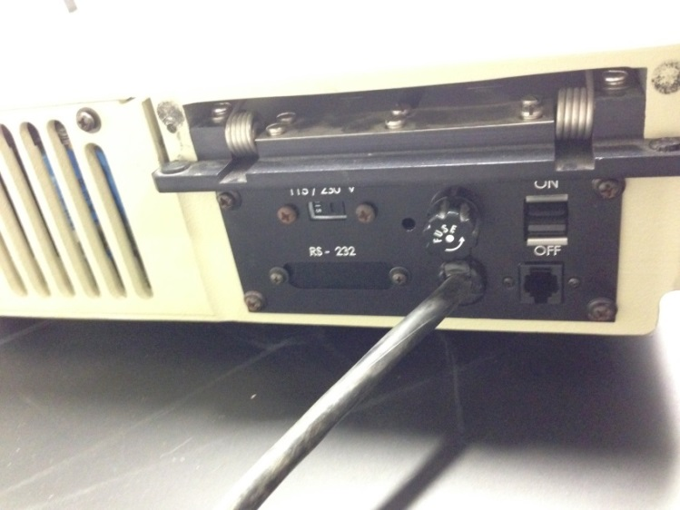
    - Sample size must be a minimum of 1 inch by 1 inch.
    - Gently press down on wafer with handheld probe until measurement is complete. Results will be shown on the display.
- Ending The Session

    - Log off TUMI.
    - Return the handheld probe at the reception desk.

- Appendix
  - Programmable Operation
- Measure Resistance V/I (Ohms) Measurement range: 0.25e-3 to 99.9e3
- Press “V/I” button, light should illuminate.
- Press “PRGM” button.
- For samples with a diameter greater than 2.5 inches enter 1.
- Depress the “PRGM” button.

- Measure Sheet Resistivity R=ρ/T (Ω/sq) Measurement range: 1.1e-3 to 4.50e5
- Press “SHEET” button, light should illuminate.
- Press “PRGM” button.
- For samples with a diameter greater than 2.5 inches enter 1.
- Depress the “PRGM” button.

- Measure Slice Resistivity ρ=RT (Ω-cm) Measurement range: 4.19e-5 to 17.1e3
Must perform Operation Procedure A 1ST
- Press “SLICE” button, light should illuminate.
- Press “PRGM” button.
- Enter thickness in angstrom (Å), micron (μm) or MIL.
- Press “STORE” button
- Press “PRGM” button and that is your answer.

- Measure Thickness Measurement range: thickness up to 2.43e-5
- Can do this measurement assuming know resistivity (Must perform C 1st.)
- Press “THICK” button, light should illuminate.
- Press “PRGM”.
- Enter the slice resistance in Ω-cm.
- Press “STORE” button
- Press “PRGM” button and that is your answer.

  - Error Codes
    - Pressing CLEAR will reset most errors.
