

Flexus 2320

Standard Operating Procedure Rev. 2026-01

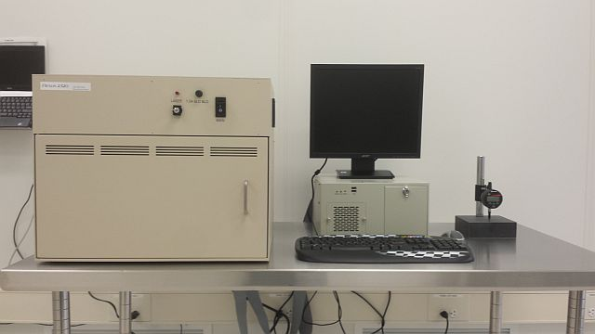

  - Application

The Flexus 2320 determines wafer curvature by measuring the angle of deflection of a laser beam off the surface 6”, 4”, 3” and 2” diameter substrates. Film stress is determined by comparing the change in radius of curvature of the substrate, with and without the film. This means that the substrate and the film must be optically reflective in the wavelength used. Because semi-transparent films may absorb light (depending on the incident wavelength/angle and the film thickness/refractive index) the Flexus 2320 has two wavelengths (670 nm and 750 nm) to accommodate various films.
  - NRF Contact

David Hays

Table of Contents
1. Safety information 3
2. Prerequisites for use 3
3. Main Unit Overview 4
4. Operation 4
4.1. Start Up 4
4.2. Sample Loading 4
4.3. Process Programs 6
4.4. Stress Measurement 7
5. Managing Data 8
5.1. Saving a scan 8
5.2. Saving a graph 8
5.3. Create a pre, post and delta deflection graph 8
5.4. Create a stress uniformity graph 9
5.5. Recalculate stress 9
6. Ending The Session 9
7. Measurement Errors 9

- Safety information
- The user must be aware of laser emission from the Flexus system at all times. The system is safety interlocked to prevent laser emission while the door is open. Anyone caught defeating this safety interlock will have access to this system revoked.
- Prerequisites for use
- User of the RSC facilities.
- Up-to-date hazardous waste training.
- Training by staff.
- User will be responsible for lost or damaged equipment due to negligence. Negligence means not following the SOP, not asking staff for assistance, intentionally damaging items, etc.
  - Users are not allowed to make ANY modifications to the materials database in the Edit menu
- Main Unit Overview
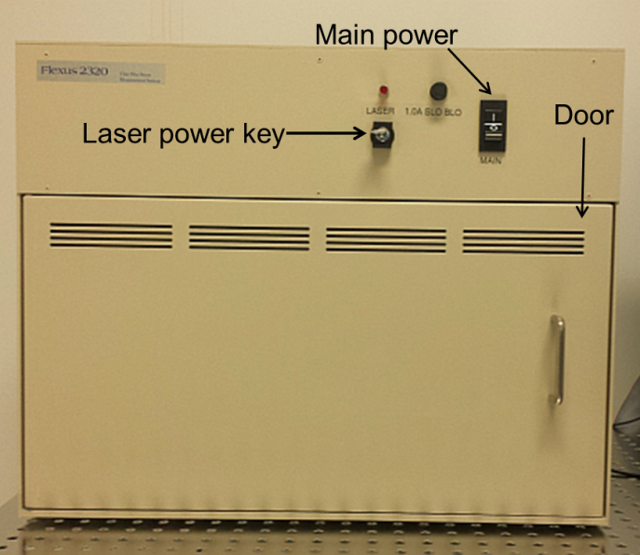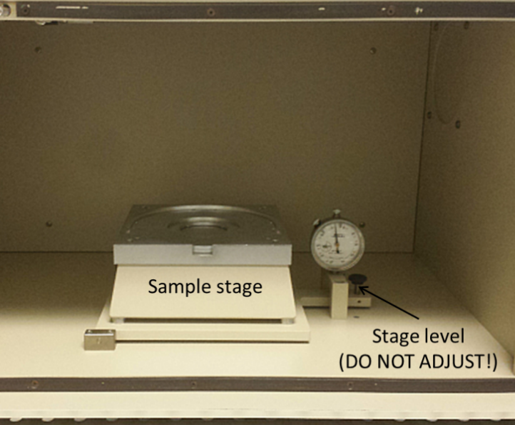
- Operation
  - Start Up
    - Turn Log on to the TUMI
    - Turn on Main power
    - Turn on the laser by turning the key clockwise to the vertical position. The indicator light above the key will illuminate.
    - If not already running, Start the WinFlx software by double-clicking the icon
    - When starting the software, it will ask for a user name. Select User 1 or create your own by clicking on “New”.
    - Creating a new user will create a folder for all your files to be saved to.
    - If the software is already started, you can login to your user name or create one by going to “Edit” then “Users” then “Add/Select”. In the new window find your login name or add a new on by clicking on “New”
To keep file management under control, please create only one user name per person!
  - Sample Loading
    - The tool has the capability to measure 6”, 4”, 3” and 2” diameter substrates (it cannot measure pieces or samples that are not round). For a 6” substrate, simply place it on the stage, face up, without any inserts with the flat at the bottom.
    - To load smaller diameter samples, you will need to place one of the inserts (shown below) on the stage first.
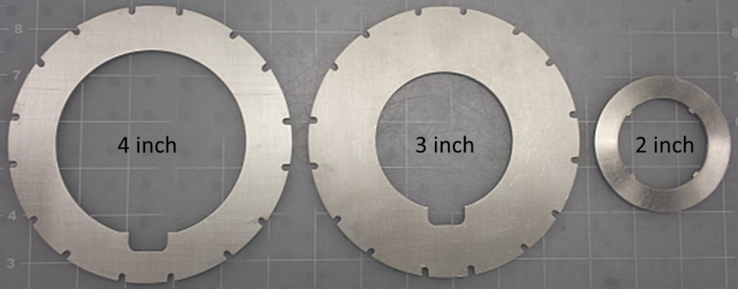
    - For a 4” or 3” substrate, load the appropriate insert for the diameter of your wafer. There are alignment pins on the stage that the insert will lock into. The wafer flat area should be at the bottom as shown below.
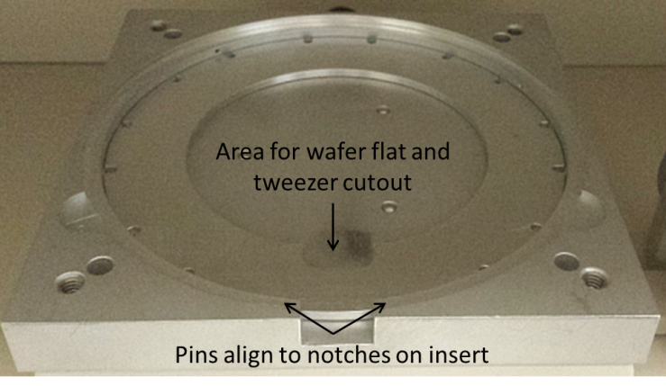
    - Loading a 2” sample requires the use of all three inserts. Load the 4” insert first, then place the 3” on top, and finally place the 2” insert inside the 3” cutout as shown below.
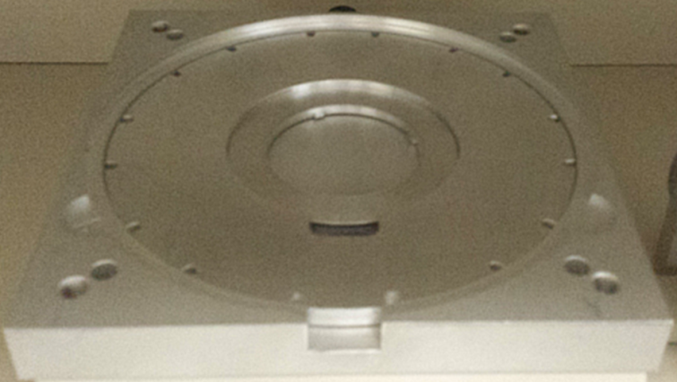
    - When your substrate is loaded, close the door and check that it is level. Go to “Utilities” then “PC ports and diagnostics & laser status”. At least one of the lasers should say OK.
If neither laser says OK, ensure that the key is on. Contact staff if both lasers indicate a stage adjustment is needed. DO NOT ADJUST THE STAGE YOURSELF.
  - Process Programs
    - You can set up a process program by going to “Edit” then “Process programs”. The pop-up window and parameters are explained below.
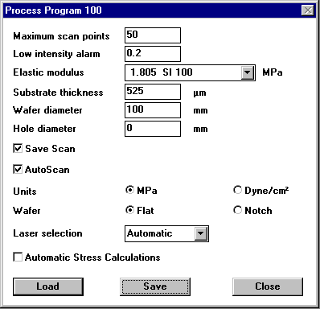
    - Maximum scan points – This number cannot be changed from 50 scan points.
    - Low intensity alarm – This will notify you if the laser intensity drop below the set value. Keep at 0.2
    - Elastic modulus – The biaxial stress modulus of the substrate. Choose your substrate from the pull-down menu.
    - Substrate thickness – Enter the thickness of the substrate in microns. See Section X “Measuring substrate thickness”
    - Hole diameter – Only used for donut shaped substrates with holes. Keep at 0.
    - Save scan – Check this option to save the data
    - Auto scan – Make sure this is checked. This will measure the inner 80% of the substrate diameter.
    - Units – Select either MPa or dynes/cm2
    - Wafer – Choose the “Flat” option
    - Laser selection – Set this automatic. This will allow the tool to determine which laser has the best intensity and select it.
    - Automatic stress calculations – The tool already calculates stress automatically. This box does not change anything. Leave empty.

    - To load a previously saved program, click on the “Load” button, select the program from the list and click “OK”.
  - Stress Measurement
    - For the first measurement without a film, go to “Measure” then “First (No film)”.
    - Enter a file name (8 characters max) - required
    - Enter an ID (16 characters max) - required
    - Enter optional comments (12 characters max)
    - Enter the thickness of the substrate in microns (Use the Starrett thickness gauge to obtain an accurate measure of substrate thickness)
    - Click the “Measure” button to start the scan
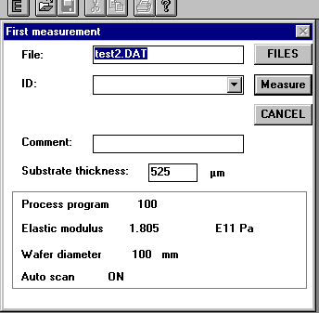
    - After the measurement is complete, the tool displays the substrate deflection and light intensity graphs.
    - To measure the stress after the film has been deposited, go to “Measure” then “Single”
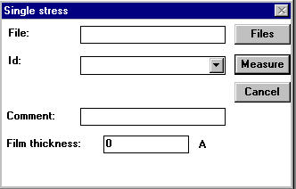
    - Enter the same file name and path as for the no film measurement. If you can’t recall the file name, choose the “Files” button to display the file selection box and locate your file.
    - Enter the same ID as entered for the no film measurement. If the correct file name has been chosen, simply select the proper ID from the pulldown menu.
    - Enter and optional comment (12 characters max)
    - Enter the film thickness in Angstroms (Use the Filmetrics, ellipsometer or Dektak 150 to obtain an accurate measure for the film thickness)
    - Click the “Measure” button to start the scan
    - After the measurement is complete, the tool displays the substrate deflection and intensity graphs, as well as the measured radius and stress.
    - A negative value indicates compressive stress
    - A positive value indicates tensile stress
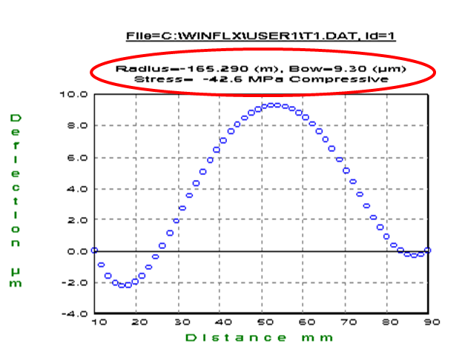
- Managing Data
  - Saving a scan
- Each scan is automatically saved (50 data points max), so you do not need to do anything.
  - Saving a graph
- To save a particular graph, simply select the graph and go to “File” “Save as”. Graphs can only be saved as a grp file and can be opened in excel as a space delimited file.
- To get the graph/data off of this computer, you must save it to the A drive (Floppy drive). Diskettes can be picked up in the holder just outside the door to the cleanroom.
- Go to the offline computers in the NW corner on the first floor and use their floppy drives to save to your thumb drive.
- Return the diskette to the holder when finished.
  - Create a pre, post and delta deflection graph
- Go to “Analysis” then “Record comparison”
- Select the file
- Highlight the line that had no film. Go to “Edit” then “Tag as first”
- Highlight the line that had the film. Go to “Edit” “Tag as single”
- Click on “Deflection” and the graph will be displayed
- To save, see section 5.2
  - Create a stress uniformity graph
- Go to “Analysis” then “Record comparison”
- Select the file
- Go to “Stress” then “Uniformity”. Keep the default settings
- Click on “Calc stress” and the graph will be displayed
- To save, see section 5.2
  - Recalculate stress
- If you later find that the values for the substrate or film thickness were wrong, you can edit the file and update the stress.
- Go to “Edit” then “Data files”
- Select the file
- Change a thickness value and the stress will automatically update
- To save, see section 5.2
- Ending The Session
    - Log off TUMI
    - Turn off the laser
    - Turn off the main power
- Measurement Errors
- Wafer position and orientation can create large sources for error. Use the placement rings
- Entering the wrong substrate thickness. For every percent that the thickness is wrong, the stress percent error roughly doubles
- Entering the wrong film thickness. For every percent that the thickness is wrong, the stress will be roughly the same percent error
- The literature with the tool reports a 1 sigma error of 1MPa for a 1um film on a 525um thick silicon wafer. Thicker films on thinner substrates result in smaller error, while thinner films on thicker substrates result in larger errors. For instance, a 100A film on a 675um thick substrate results in an error of ~100MPa
- The stress value reported is the average stress across the substrate. There are higher and lower values depending on position. To see these values, you need to look at the stress uniformity (See Section 5.4).

