

FEI Nova NanoSEM 430

Standard Operating Procedure Rev. 2026-01

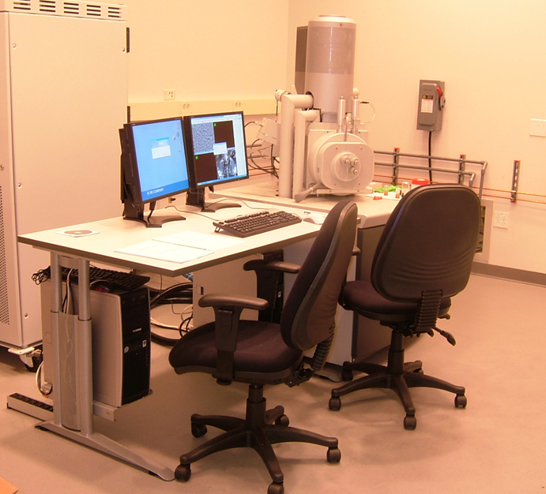

  - Application

The FEI Nova NanoSEM 430 is a state-of-the-art SEM that utilizes a field emission electron source and immersion lens technology to obtain resolution below 1 nm. The NanoSEM is capable of imaging from 8X to 300,000X, working distance permitting. Accelerating voltage can be varied from 50V (with beam deceleration) to 30kV. It features a motorized XYZ stage with full 360° rotation and -5° to 45° tilt and can hold a full 4” wafer.
  - NRF Contact

Andres Trucco
Table of Contents
1. Safety information 4
2. Prerequisites for use 4
3. Pre-Operation 5
4. Software Navigation 5
4.1. Top Tool Bars 6
4.2. Right side tool bars 7
5. Sample Loading Procedures 10
5.1. Stage Status 11
5.2. Venting Chamber 11
5.3. Sample Mounting 11
5.4. Securing SEM Stub Into Stage 11
5.5. Closing Chamber Door 11
5.6. Evacuating Chamber 12
6. SEM Star Up 13
6.1. Turning HV ON 13
6.2. Selecting Beam Conditions 13
6.3. Getting a Live Image. 13
6.4. Adjusting Magnification and Focus 13
7. Calibrating Stage Z with Focal Working Distance 14
8. Image Optimization 15
8.1. Source Tilt Adjustment 15
8.2. Aperture Alignment 15
8.3. Stigmators Adjustment 15
8.4. Scan Speed 16
9. Detectors 16
9.1. Mode 1 (Field Free Mode) 16
9.2. Mode 2 (Thru Lens w/immersion) 16
10. Image Capture 17
10.1. FEI software 17
10.2. Image Capture – Gatan software 17
11. Sample Unloading 19

- Safety information
- High Voltage - High Voltage is used throughout the system. System maintenance may only be performed by the FEI service rep or NRF Staff. Do not remove any tool covers or defeat any interlock on this system.
- Moving Components - The User must observe caution when opening and closing the chamber door to ensure sample and stage clearance. Any neglect in sample loading/unloading will result in damage to the SEM column.
- Pinching Hazard – the door to the SEM chamber can pinch fingers when closing. Use caution.
- Prerequisites for use
- User of the RSC facilities.
- Up-to-date hazardous waste training.
- Training by staff.
- User will be responsible for lost or damaged equipment due to negligence. Negligence means not following the SOP, not asking staff for assistance, intentionally damaging items, etc.
  - No liquids
  - No biological materials such as plant or animal tissues, insects, etc.
  - Do not use double sided scotch or Kapton tape

- Pre-Operation
  - Tool Reservations may be made via the NRF Reservation Page. http://nimet.ufl.edu/servicecenter/resources/default.asp
  - Change gloves. WARNING No solvents or liquids are allowed near the machine, change your gloves before operation!! Wear gloves while handling the samples and sample holders to reduce contamination.
  - Log into the TUMI computer in room 125 to access the instrument.
- Software Navigation
The FEI Nova NanoSEM 430 is a menu intensive system. The main screen (below) consists of a top menu bar, top tool bar and right-side tool bar. The right-side tool bar consists of 6 different toolboxes, of which 3 are used in basic operation. The right-side tool bar changes with the selected icon on top.

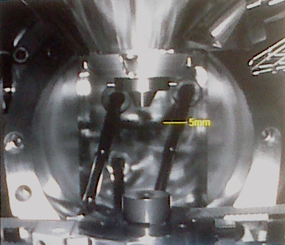
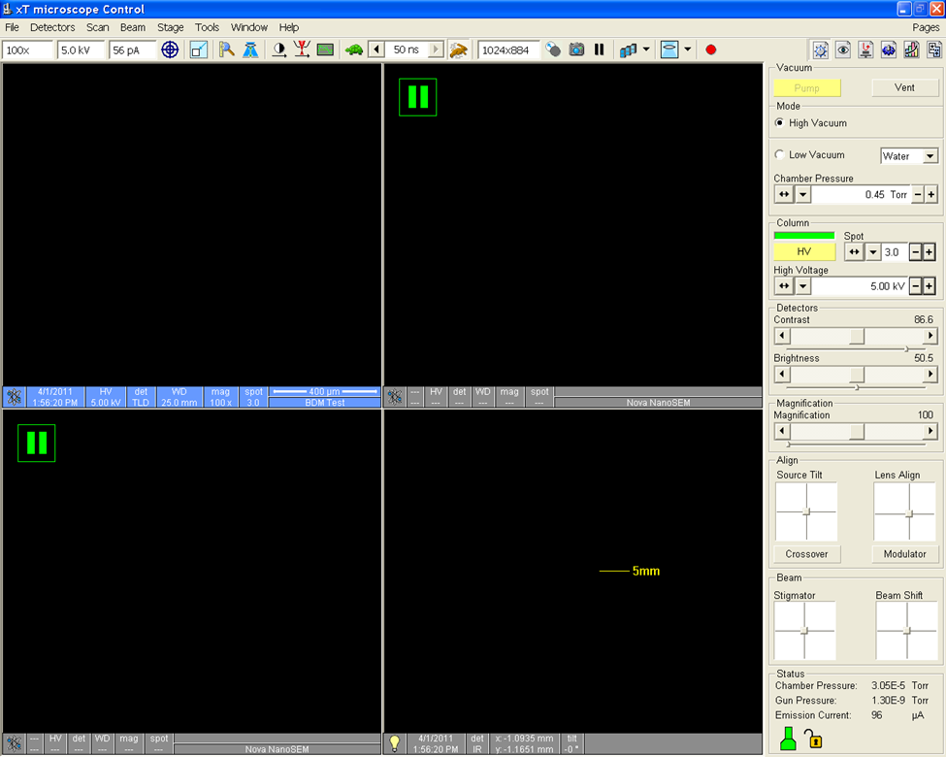

  - Top Tool Bars
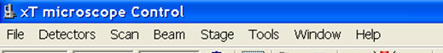
    - Menu Bar

    - Top tool Bar

Right Side Tool Bars – these are selected to control the electron column (labeled Beam Control), stage (labeled Navigation) and measurement tools (labeled Processing).

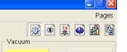

  - Right side tool bars
    - Beam Control
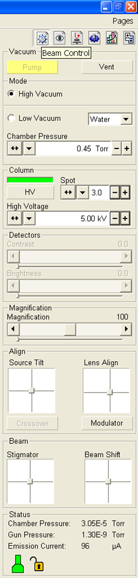
This toolbar is to control the electron beam
parameters.

Vacuum – the user selects “Pump” or “Vent”

Mode – High Vacuum Mode ONLY

CAUTION  CAUTION
Do not select Low vacuum mode.
This detector is only installed and
operated by NRF staff.

Column – user enables the high voltage “HV”. User selects the spot size and accelerating voltage.

Detectors – User sets the contrast and brightness to desired levels

Magnification – User selects the desired magnification value.

Align – User adjusts the “Source Tilt” to center illumination in the cross mark and “Lens Align” to minimize image wobble.

Beam – User adjusts the “Stigmator” for optimum focus and can move the scan field with “Beam Shift” at high magnification.

Right clicking in these alignments’ boxes will open a short user menu for course/fine adjustment and zeroing the settings.

    - Navigation
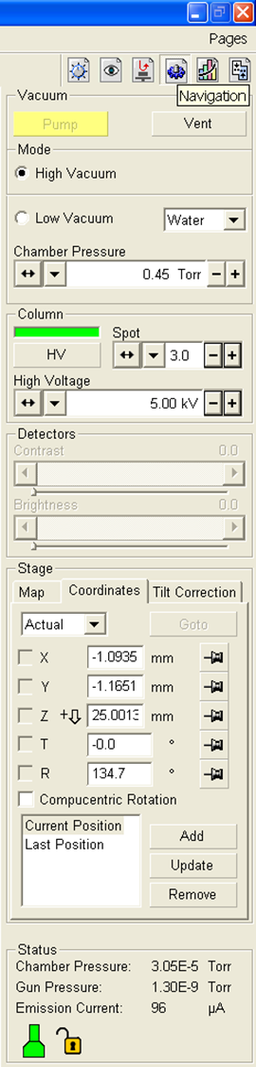

This tool bar is to control stage movement. Several buttons from “Beam Control” are replicated and serve the same function.

Stage – user inputs values for stage movement and position. There are 3 tabs in this section, Coordinates is the most useful. The user can select to lock a coordinate and use actual or relative positions.

When entering stage position values, execute the stage action by selecting the [Goto] button. This button becomes a [Stop] button during the stage movement and is very useful to stop movement if an error occurs.

The type of movement must be selected. “Actual” and “Relative” are commonly used modes. “Actual” moves the stage to that actual position. “Relative” moves the stage relative to the current position.

It is a good procedure to have the IR chamber view in operation during stage movement to avoid the sample/column collision.

CAUTION CAUTION
The Z axis motor moves very fast. Use caution when moving the sample within 10mm of the end of column.
Never use COMPUCENTRIC Rotation while the stage is tilted. This will crash stage into column.

The user can also move the axis knobs on the stage motors to position the sample.

On the active image, the user can double left click on a feature to move it into the center of the image or press and hold the scroll button to drag the sample in any direction.

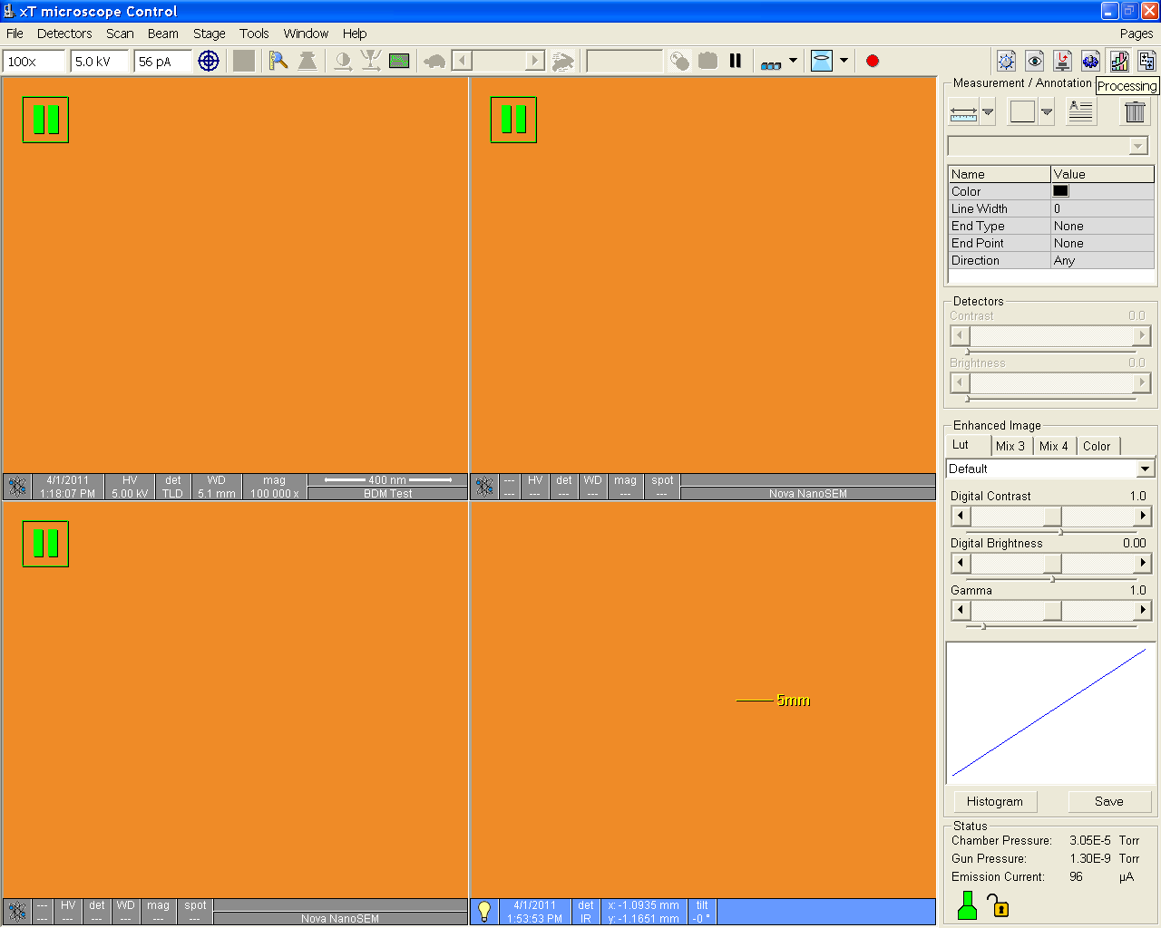

    - Process

This tool bar provides measurement tools for image analysis.

Measurement/Annotation – user selects line, area and text tool to edit image.

Enhanced Image – User selects different tools to digitally enhance the image.

Please make sure Enhanced Image is set back to Default if modified. This also changes the live image.

Reference will be made to these menus and tool bars throughout this SOP.

- Sample Loading Procedures
Clean gloves must be worn while handling the sample holders and loading/unloading the samples. This reduces the amount of contamination on the holders and in the chamber, providing a longer life of the high resolution capabilities.

CAUTION CAUTION
BE SURE THE CL MIRROR IS FULLY RETRACTED
BEFORE LOADING OR UNLAODING SAMPLES
FROM THE CHAMBER

To ensure the CL mirror is fully retracted, check the indicator light on the CL monochromator. If the light is GREEN, the CL mirror is fully retracted, and it is safe to proceed. If the light is RED, retract the CL mirror using the mirror position knob under the monochromator.

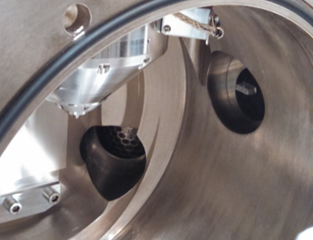

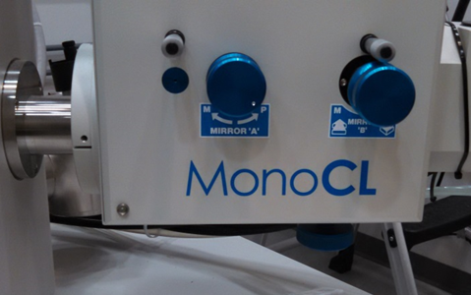


Green Light ….The mirror is fully retracted
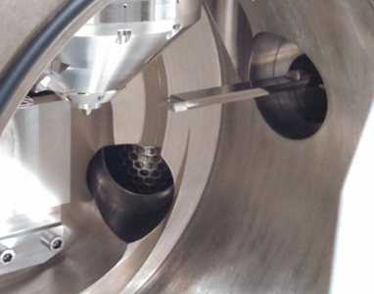

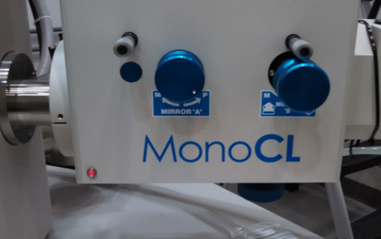


Red light…. The mirror is partially or fully extended. Mirror position knob is circled in yellow.
  - Stage Status
Confirm the stage is at its lowest position, Z to 65mm or more in the Navigation tool bar (Section 4.2.2). Set the tilt to 0° and the rotation to 180°. This places the securing screw to a convenient location. The IR chamber camera should be used to avoid a stage/column collision.

CAUTION CAUTION
Z refers to the stage height read from the lower right side of the monitor.

  - Venting Chamber
Click the “VENT” button on the top of the Navigation (Section 4.2.2) or the Beam Control (Section 4.2.1) tool bars. The system will notify you of the approximate time for venting and confirmation to continue. After 2-3 minutes, you may pull the chamber door open by using the chamber door handle.

CAUTION CAUTION
Open and close the chamber door with the chamber door handle.
DO NOT use the stage control knobs as handles.

  - Sample Mounting
Mount sample in holders with screws, vise clamp design, or 4” wafer holder. You may also use carbon tape or Cu tape to attach samples.
NO CARBON PAINT, OR PAINT OF ANY KIND, TO BE USED UNLESS SPECIAL PERMISSION IS GRANTED BY THE STAFF.

  - Securing SEM Stub Into Stage
Insert the sample mount into the SEM stage and lightly tighten the retaining screw. CAUTION – do not over tighten this screw.

  - Closing Chamber Door
Push the chamber door closed by using the chamber door handle.

  - Evacuating Chamber
Click the “Pump” button on the top of the Navigation (Section 4.2.2) or the Beam Control (Section 4.2.1) tool bars to begin chamber pump down. This will take a few minutes for the chamber to reach the mid 10-5 Torr for operation. Then the base pressure has been obtained, the “HV” icon will become available for activation.

- SEM Star Up
  - Turning HV ON
Click the “HV” icon to turn on the FE gun. Located on the Beam Control Page
  - Selecting Beam Conditions
Select the acceleration voltage and spot size from the Beam Control toolbar (Section 4.2.1) For imaging is recommended to start at 5kV and 3.0 to 3.5 spot size. For EDS, 15kEV and a 4 to 4.5 spot is recommended. These are just recommended values.
  - Getting a Live Image.
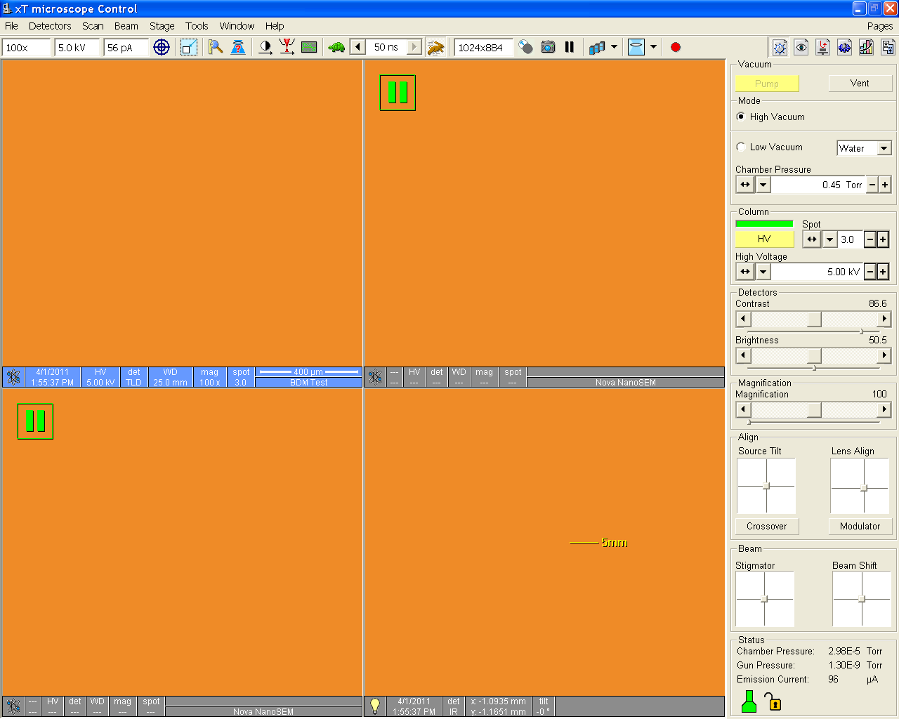
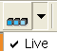
    - Select one of the imaging windows. Un-pause the SE image by clicking the pause icon (upper right hand)
    - Make sure that the imaging averaging is set to “Live”.
    - Adjust the contrast/brightness to obtain a grey scale image. You can use Auto CB.
  - Adjusting Magnification and Focus
    - Set the magnification to 200x. Focus on the top surface of your sample by pressing the right mouse button and moving it left and right. The SE image must be highlighted for focus to work. When the right mouse button is pressed, the cursor will become a double ended arrow.
    - Magnification can be adjusted with the magnification control on the Beam Control toolbar (Section 4.2.1), with the top tool bar magnification window, or by right clicking the mouse and dragging a box around your area of interest. You can also use the + - keys on the keyboard (most effective). Set the magnification of 1000x or more and refocus the image.
It is critical that your image is in focus before proceeding to the next step

- Calibrating Stage Z with Focal Working Distance
    - After the image is well focused, set the actual sample working distance by using the “link Z to FWD” icon on the top tool bar.
This will take the WD from the image window and transfer it to the Z value on the stage navigation, providing an accurate working distance for stage movements on the Z direction. Please DO NOT SKIP THIS STEP!
    - To change the working distance (move stage up), enter the working distance value into the Z box on the Navigation tool bar (Section 4.2.2). After entering this value, click the “Go To” button. The “Go To” button becomes a “STOP” button during stage travel.
    - Raise the stage in 10mm increments and focus/relink z every time so there will be a reduced chance of collision with the column or other detectors.
    - You may also highlight the IR chamber image and use the mouse scroll wheel. Hold the mouse scroll wheel down and move the mouse up or down to move the stage.
    - Use the IR chamber image to determine possible sample/column interference and to ensure no column touching with the sample. Ensure chamber view image is not paused. You may also manually raise the sample by turning the Z knob on top of the chamber door.
CAUTION CAUTION
Use caution when moving the stage close to the column to avoid collision.
After a large stage movement in Z, refocus the image and “link Z to FWD” again . Check this icon often to confirm the Z value on the stage control is accurate.

- Image Optimization
For each change in detector (Mode 1 or Mode 2), or column condition (keV or spot size), realignment of the lenses and stigmator will be required.
Select your beam condition, detector mode and working distance prior to image optimization.
Find an area of interest to optimize the beam. It helps to find a small piece of contamination or an area with a lot of topography. The stage can be moved by double clicking with the mouse over the area of interest on the SEM image. Or by holding the center scroll wheel down and dragging the mouse to move the stage.
  - Source Tilt Adjustment
Adjust Source Tilt by pressing Crossover radial button and aligning the green X on the screen with the circle. If the circle is not visible, increase contrast to 90%. Use the crosshairs to center the X with the circle. When done, depress the Crossover button adjust focus and contrast.
  - Aperture Alignment
Align the beam within the aperture by using the Lens Align crosshair on the Beam Control toolbar (Section 4.2.1). It is a good practice to clear any “Beam Shift” to center the scanning image.
    - Turn on “Modulator” (under the crosshairs) to begin image wobble. The image will go in and out of focus.
    - If you experience translation on X or Y direction, drag the crosshairs to minimize the translation. X will correct left / right shift, Y will correct up/down image shift. Adjust focus when done.
  - Stigmators Adjustment
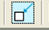
    - It is best if this procedure is done at a magnification of 30 000X or higher. Also, it is beneficial to use the small raster window for faster scan rates.
    - Adjust the stigmation with the stigmator crosshairs in the Beam Control toolbar. Adjust one axis at the time and refocus each time. You are looking for a clear image.
The sequence goes: Focus – X – Focus - Y. Redo 2 to 3 times.

  - Scan Speed
    - You may change the scan speeds, from continuous mode to line scans, and image averaging from the top tool bar.
Note: some scan modes will default to imaging averaging which can cause confusion during image optimization. You can reset the averaging mode to “live” to get a fast image refresh rate.
- Detectors
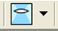
The system has 3 different SE detection modes, the standard ET detector (Mode1), Thru Lens and Thru Lens w/immersion (Mode2). The highest image resolution will be achieved with Mode 2. Detectors are selected by opening the Detector menu form the top menu bar (Section 4.1.2).
  - Mode 1 (Field Free Mode)
Mode 1, also known as search mode, allows you to zoom all the way out to 15-30x. This allows you to search the sample for an area of interest. If you are imaging from 30x to 2000x magnification, you can stay in mode 1 and do your image optimization (section 8). If higher magnification images are needed with better quality you may need to find your area of interest first and switch to mode 2, Immersion mode.

  - Mode 2 (Thru Lens w/immersion)
To use the Thru Lens w/immersion(Mode2), the following conditions must be met:
- Less than 18kV
- Above 2000x magnification
- Less than 7mm working distance
To select Mode 2, click the Lens Selection icon on the top tool bar and select “immersion”. If the “immersion” in not selectable check your SEM conditions.
If Mode 2 is selected, you need to readjust your beam (section 8)

- Image Capture
  - FEI software
    - Select a line scan (usually 12us) then press the image pause from the top tool bar to stop the scan.
    - Open the “File” menu on the top menu bar and select “Save As”. Save all images to the SPC Shared Data on spc-npe102 directory found on the desktop. This will save the images in the support computer (located to the left of the main computer). The keyboard and mouse for this computer are located on the keyboard tray under the desk.
Once the images are saved, remove them from the computer via USB drive. Only remove images from the support computer. The USB slots in the main computer are blocked and are inaccessible.
  - Image Capture – Gatan software
Superior images can be acquired with the Gatan Digital Microscope software. The program screen shot is below with the image capture menu highlighted.
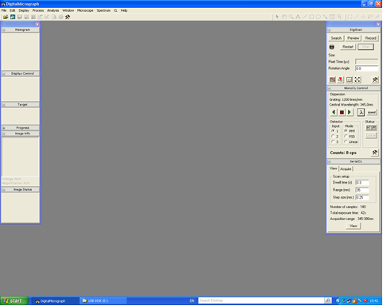

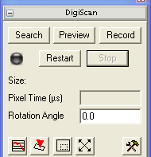
    - Use the search, preview or record modes to capture your image. Each mode has a different resolution. The space bar will trigger a scan stop at the end of the image scan.
    - Captured images should be saved in the following format:
- In the FILE pull down menu, select SAVE AS.
- The default format is the Gatan DigitalMicrograph format (*.dm3).
    - It is preferred that you save the images in this format for future editing and data creation. The Gatan format stores a lot of mage resolution data and this makes future image edits easier and more accurate. However, only Gatan DigitalMicrograph can read this *.dm3 format.
    - If the image format is to be other than the Gatan format, select SAVE DISPLAY AS in the FILE menu. This will allow the user to select the type of image file format desired. Gatan DigitalMicrograph can save images in standard formats such as TIFF, GIF, BMP, and JPEG.

- Sample Unloading
    - Ensure the CL mirror is fully retracted.
    - Lower stage using the mouse on the CCD camera window(scroll wheel and mouse down) to separate the sample from the pole piece to at least 15mm WD.
    - Lower Z to 65mm, set tilt to 0°, center X and Y, set rotation to 180°.
    - Click the “HV” button to turn off the beam.
    - Click the “VENT” button on the software to release vacuum.
    - Loosen the retaining screw 1 turn, do not remove the screw, to remove the stub holder.
    - Close the chamber door and press PUMP to evacuate the chamber.
    - If you modify a sample holder, remove screws or clips, you must place it back into its original state. Other users depend on these holders to mount their samples. Please let us know by TUMI log off note if any of sample holders are taken apart or are missing parts.
    - Log out of the TUMI computer in room 125 at the end of your session.

Please close the room door behind you. SEM room is limited access only.

