
Aerosizer TSI PSD 3603
  - Standard Operating Procedure (SOP)

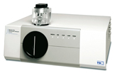
  - Application
The TSI PSD3603 (Aerosizer) measures particles one at a time in the range of 0.20 - 700 microns. The particles may be in the form of a dry powder or may be sprayed from a liquid suspension as an aerosol. The particles are blown through the system and dispersed in air to a preset count rate. The Aerosizer operates on the principle of aerodynamic time of flight. The particles are accelerated by a constant, known force due to airflow and are forced through a nozzle at nearly sonic velocity. Smaller particles are accelerated at a greater rate than large particles due to a greater force-to-mass ratio. Two laser beams measure the time of flight through the measurement region by detecting the light scattered by the particles. Statistical methods are used to correlate the start and stop times of each particle in a particular size range (channel) through the measurement zone. The time of flight is used in conjunction with the density of the particles and calibration curves established by Amherst (see: Aerosol Science & Technology 29:433-441, 1998) to determine the size distribution of the sample.

Contents
Desktop login 3
Setting up a new sample analysis 4
Cleaning the System 6
Disassemble the PDA Unit 6
Clean the disassembled pieces 10
Reassemble 10
Shutdown Procedures 11
Particle Trap Cup 12
Sample pathway 13
How Size is Calculated 14

Desktop login

username TSI, Password: (blank, no password)
The operating procedures are meant to serve as a reminder/ general guide on instrument operation. Users should consult the instrument and/or software manuals for clarifying explanations and additional guidance.
The Aerosizer is currently configured for powdered sample analysis. Please consult RSC staff if aerosol analysis is needed.
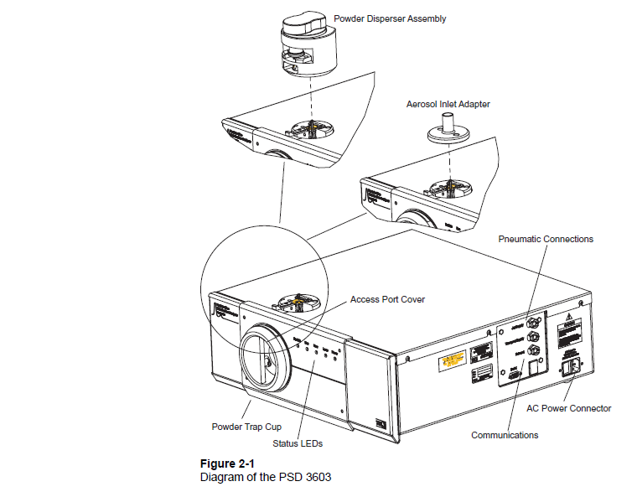

Setting up a new sample analysis
- Turn on power to system, verify the green power LED is on
- Open the Particle Instrument Manager software on the computer desktop.
To start the PIM program, proceed as follows:

From the Windows desktop press the Start menu and then select Particle Instrument Manager from the menu or double-click the PIM icon.

The Particle Instrument Manager desktop appears and the data windows for the last run worked with are displayed.
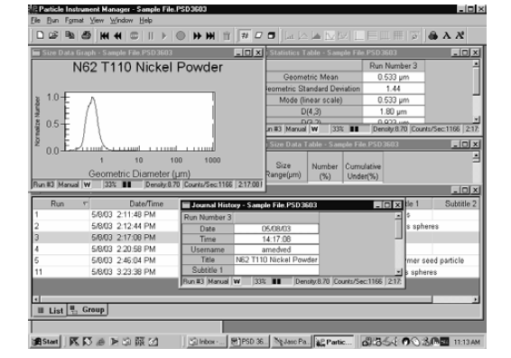

- Select File > New
- Navigate to your folder, and name file appropriately, the file format is a proprietary .PSD3603 format. If you are adding runs to an existing data file, select the project of choice and select open.
- Select Open when file name and location are correct. A run list window will open.
- Once the run list is open, select Run > Start Data Collection. This opens the properties dialog box.
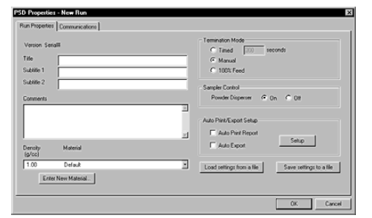
- Enter a title, and select the appropriate settings for termination mode, and material properties. You should not need to change other settings. If needed add your material with the “Enter new Material” option, you need to know the density of the material you want to add.
- Check the communications tab shows a connection to COM1 as the PSD3603 instrument. DO not select ok until sample is loaded.
- Load the sample powder into the sample cup.
  - Slide the sample cup retaining lever to the left
  - Slide the particle cup out of the sample holder
  - Separate sample cup by pulling two halves apart (do not use tools) and place cup with O-rings up.
  - Place 1-5mg of sample in the cup base and reassemble cup, the two halves should fit tight.
  - Replace cup in holder, and slide retaining lever to the right
- Select OK to begin sample analysis
*Data is collected at a rate of one sample per second. Each sample is the sum of all measurements made for the run since data collection began.

In timed mode the program will automatically terminate after the elapsed time chosen, in manual mode you manually press the stop option to end the analysis, in 100% feed mode terminates after 20 seconds of maximum feed rate dispenser (cannot be used if powder dispenser is turned off).

Cleaning the System
The most accurate and repeatable results are obtained when the system is disassembled and cleaned between each test. The pieces should be cleaned with isopropyl alcohol, and dried with compressed air.

Disassemble the PDA Unit
IMPORTANT: Do not use any tools to complete these steps
Slide the sample cup out, and separate the two halves.
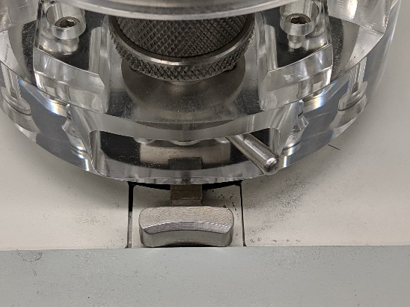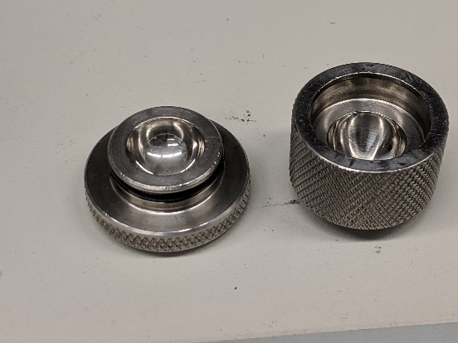

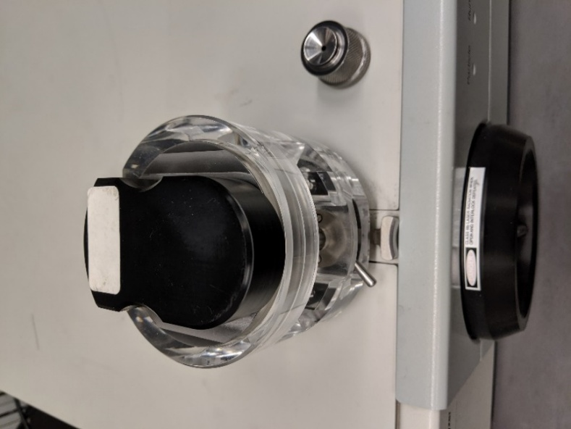
Slide the dispenser cover off the transport housing and set aside, this piece does not require cleaning.

Remove the vertical Jet (larger) by twisting and lifting off the housing, lay pointing up on a clean surface.
Remove the Dispenser pin from the housing by twisting and lifting up, be cautious of long needle point. Set on clean surface, pointed tip up.
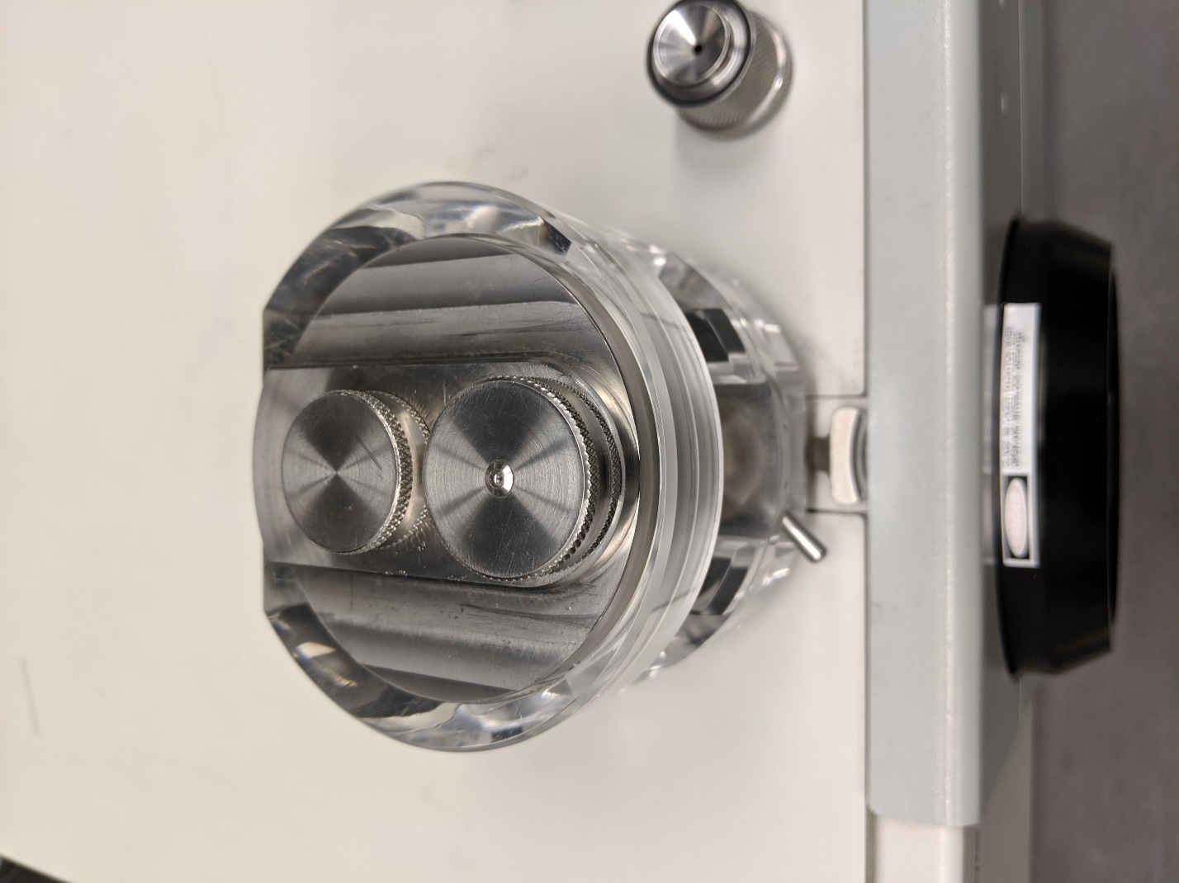
Dispenser Pin
Vertical Jet
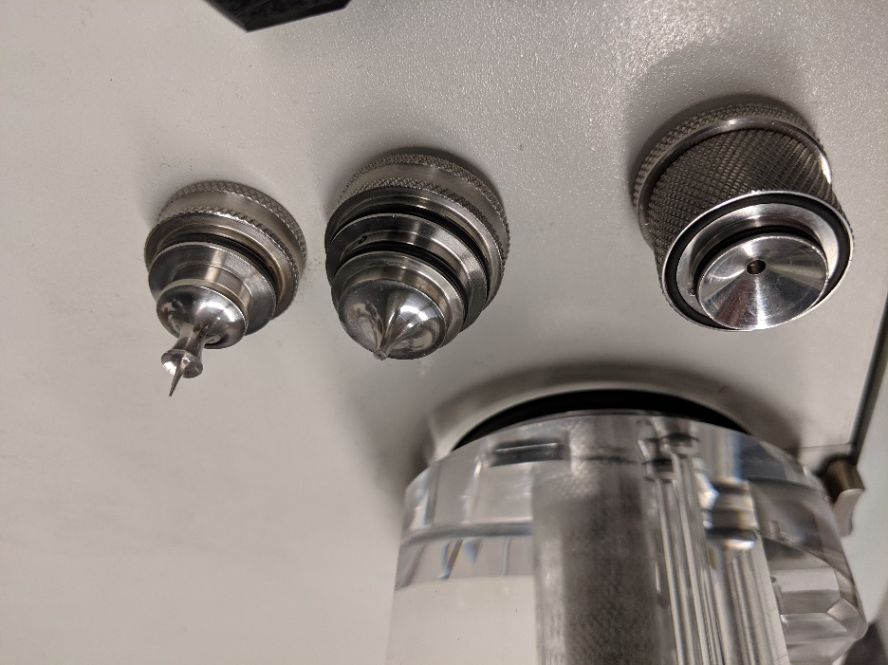
From left to right: sample cup, vertical jet, Dispenser pin

Remove transport housing by pressing release button and lifting.
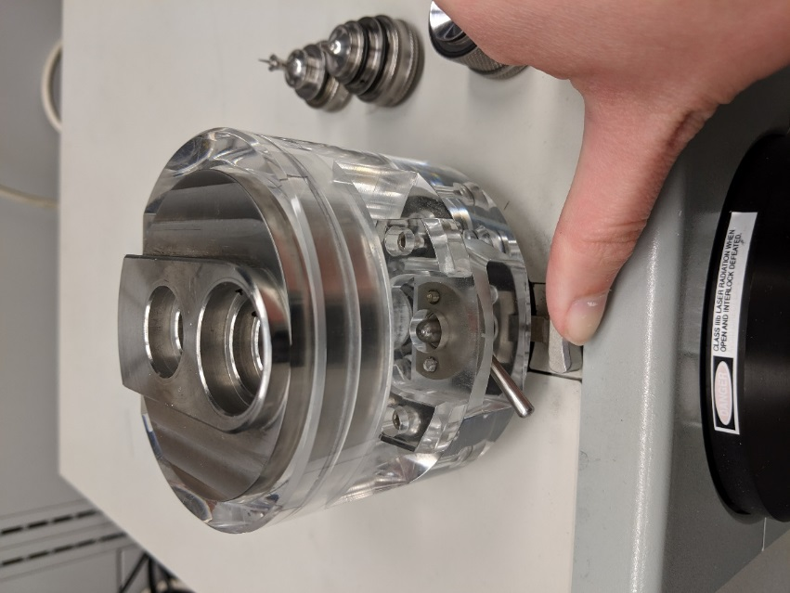

Turn housing over and remove injection nozzle assembly, lift off clear plastic dispenser housing.
Set dispenser housing aside, this piece does not require cleaning.
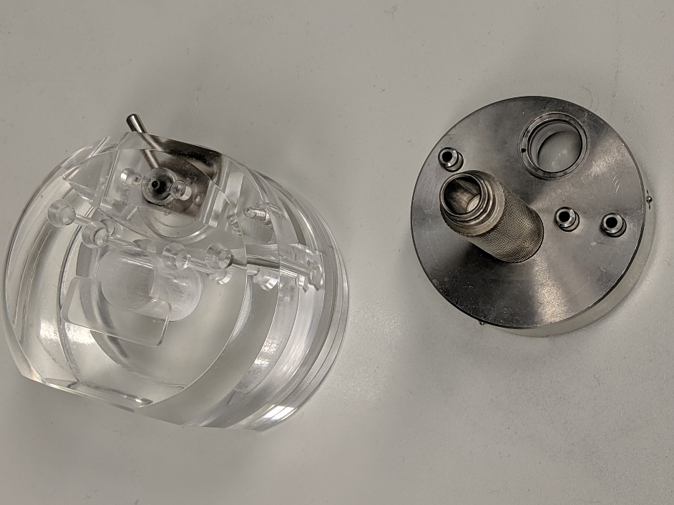
Dispenser housing Injection nozzle
With injection nozzle housing in vertical position, unscrew injection nozzle, DO NOT let the small dispenser inside nozzle to fall out. Keep the assembly in the orientation shown below and the small dispenser inside will remain in the housing while the injection nozzle is removed. Then you can remove the small dispenser left in the housing.
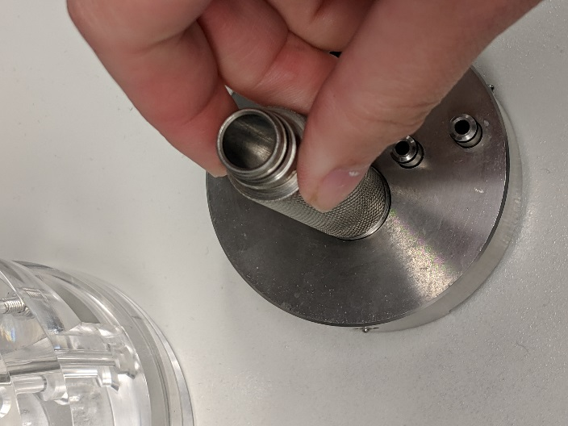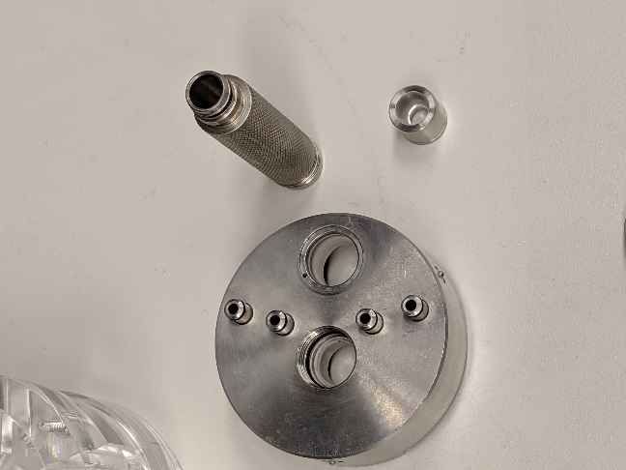
Reach into the dispenser mount on top of the aerosizer unit, and grasp the inner nozzle. Gently twist and pull straight up. Be careful to not damage spring. Lay gently on a clean surface.

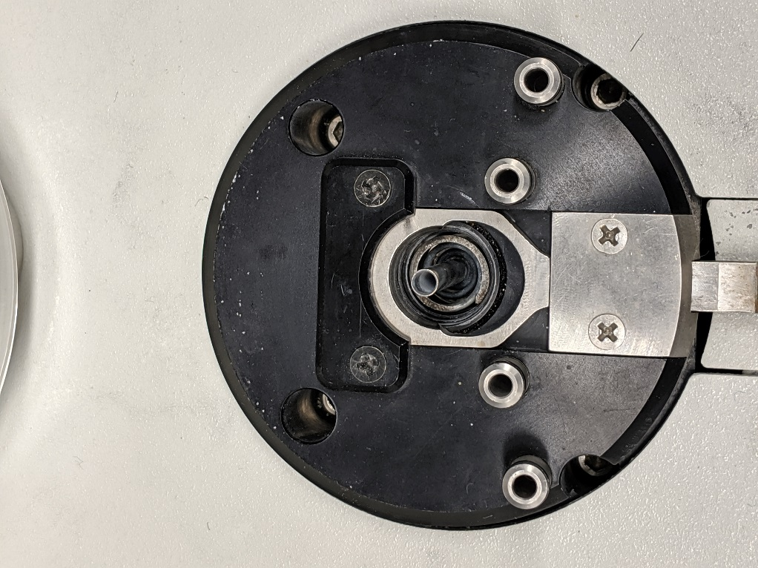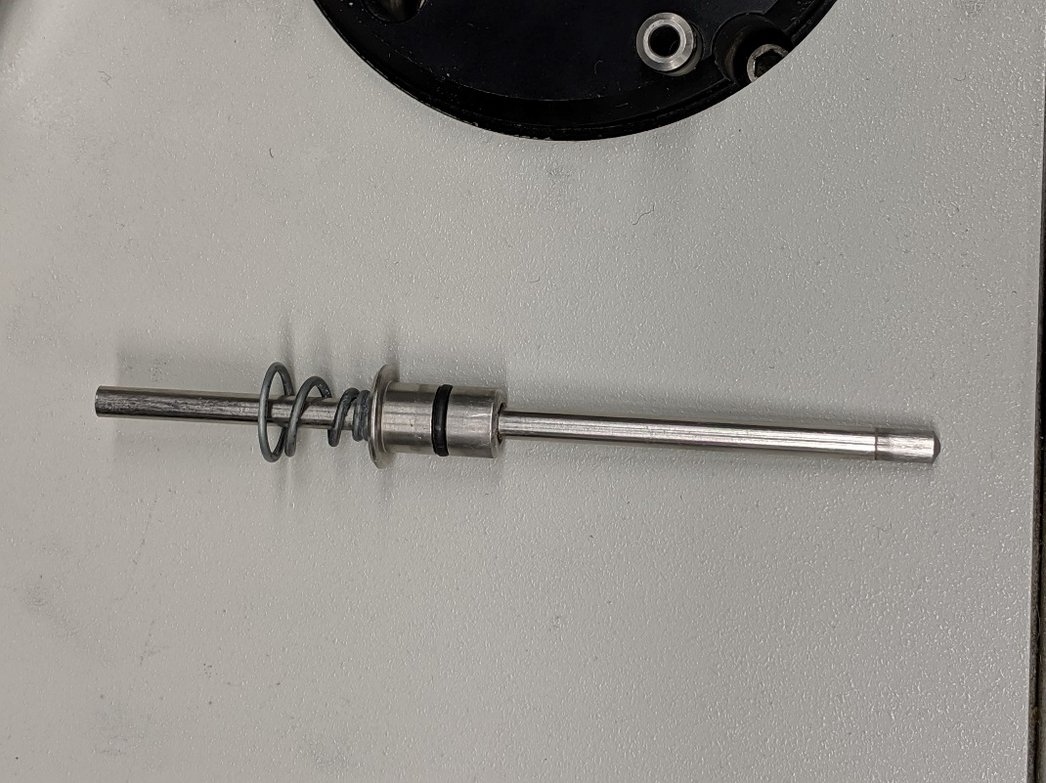

Clean the disassembled pieces
Check O-rings as you clean, and lubricate if needed. Notify RSC staff if any O-rings need changing due to wear and tear damage.
Pieces that require cleaning should be cleaned with isopropyl alcohol and dried with compressed air (available in the hood).

Reassemble
You should reassemble the clean and dry pieces following the disassembly instructions above in reverse order.
*A blank, or empty cup ran can be executed between multiple scans of the same sample or after cleaning. This can help clear the pathways of any straggler particles.

Do not remove the access port cover on the front of the machine, this area should only be cleaned by RSC staff.
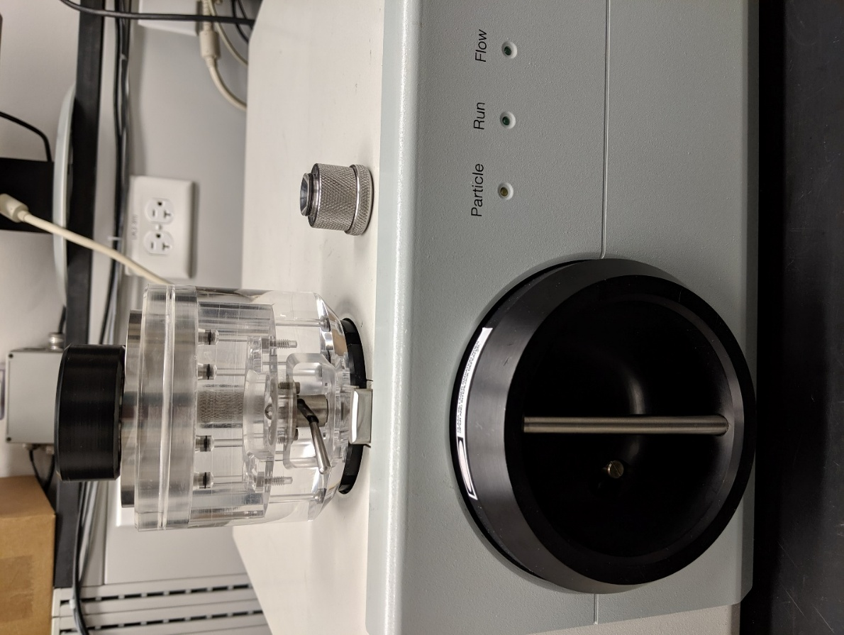
Access Port
Note: The access port cover does NOT need to be removed each time the PSD 3603 is cleaned. Remove the cover only when an “Excess scattered light detected” error message is received or after about 20-25 tests.

Shutdown Procedures
Turn off power switch on side of the aerosizer unit.
Close software after exporting and saving necessary data.
Logoff TUMI system, and clean particle trap cup.
If not done previously, disassemble and clean pieces after final analysis run.

Particle Trap Cup
The particle trap cup, located on the bottom of the instrument, should be cleaned after logging off the system, before you leave.
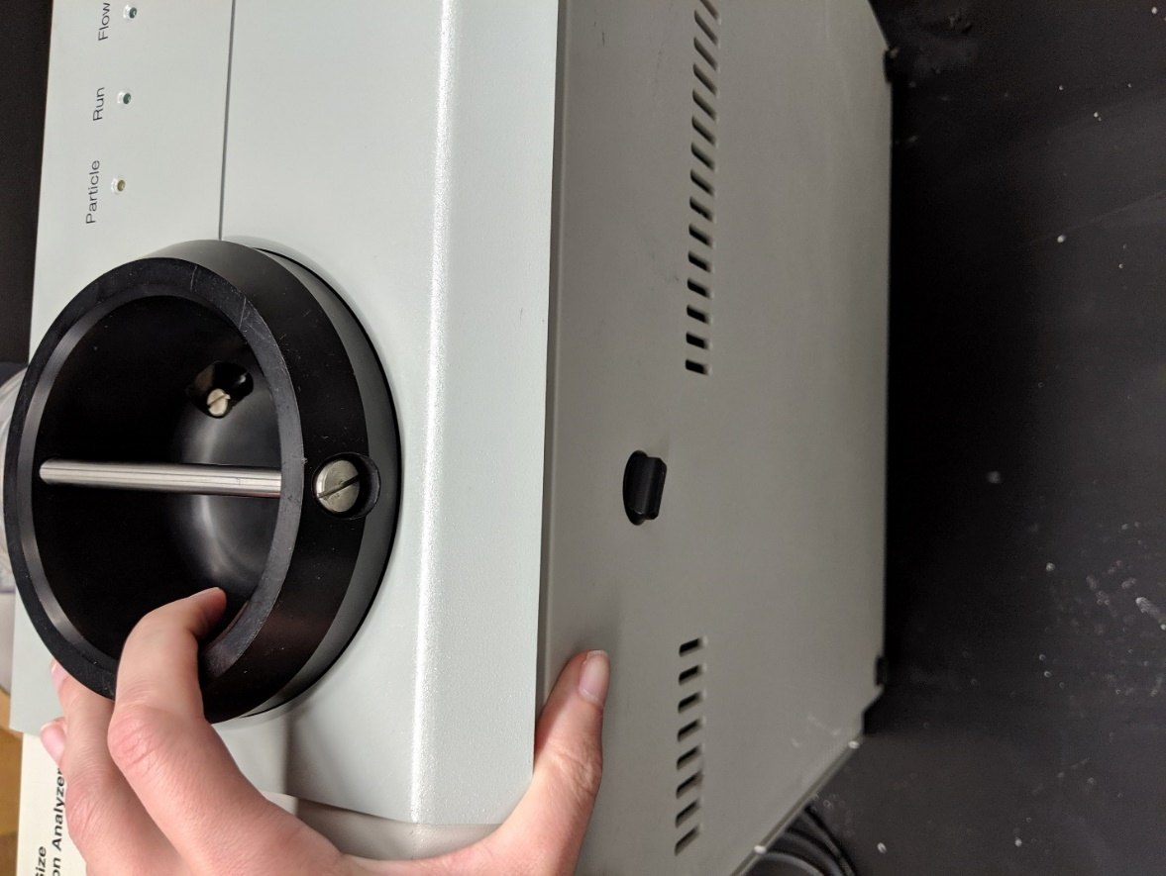
Particle Trap Cup
Turn counter clockwise to remove cup.
Gently tap out accumulated sample material
Use compressed air to blow out remaining sample. No additional cleaning is required.
Inspect O-ring for damage, notify RSC staff if damage is present, reinstall the cup turning clockwise until it stops, do not over tighten.

Sample pathway
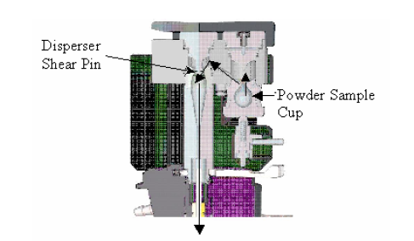

How Size is Calculated
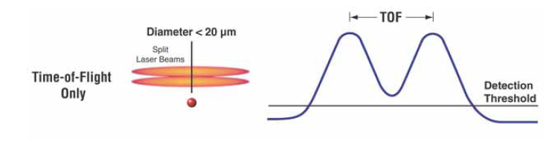
Particles between 20 and 100 micrometers in diameter are measured using a combination of Time-of-flight (TOF) and Time-in-Beam (TIB) technology. These particles produce a hybrid pulse that has a less pronounced double crest.
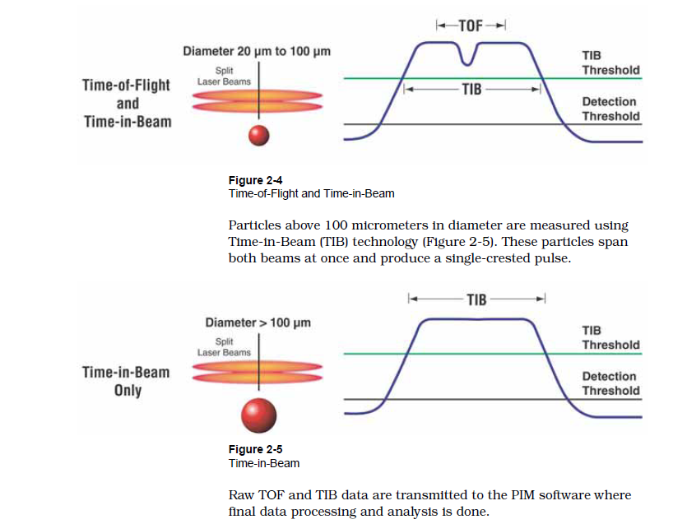
Particles above 100 micrometers in diameter are measured using Time-in-beam (TIB) technology. These particles span both beams at once and produce a single crested pulse.
Raw TOF and TIB data are transmitted to the PIM software where final data processing and analysis is done.

