

Cambridge NanoTech FIJI 200
Standard Operating Procedure Rev. 2026-01

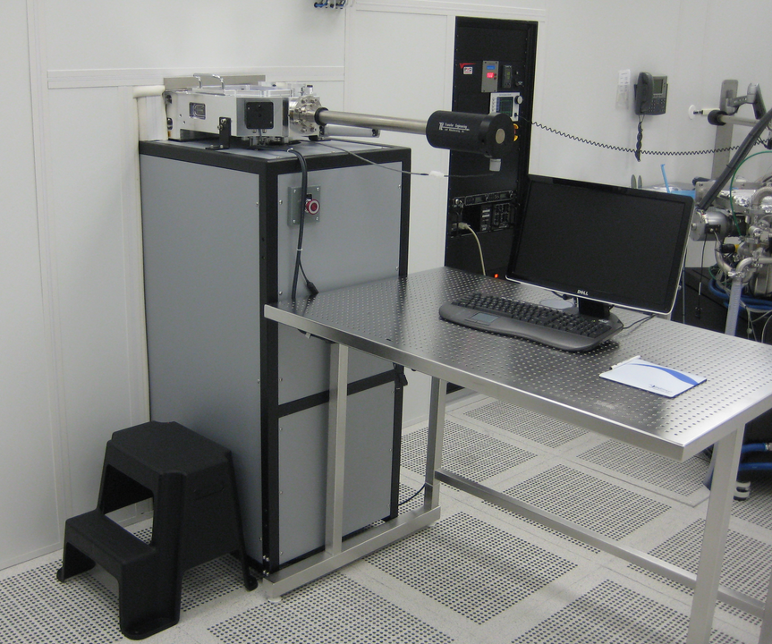

  - Application
The Fiji is a modular high-vacuum ALD system that accommodates a wide range of deposition modes using a flexible system architecture and multiple configurations of precursors and plasma gases. The result is a new generation ALD platform capable of doing thermal as well as plasma-enhanced deposition.

The system contains a load/lock chamber for loading substrates external to the process chamber. The process chamber has a gate-valve to maintain optimum process conditions and minimizing temperature cycling times. EMO buttons are provided on the front and rear of the system.

  - NRF Contact
Andres Trucco

Table of Contents
1. Safety information 3
2. Prerequisites for use 3
3. Pre-Operation 4
4. Hardware Overview Images 5
5. User Interface Overview 6
6. Operation 8
6.1. Sample loading 8
6.2. Loading recipe and running processes 11
6.3. Sample unloading 13
6.4. Standby Mode 15
7. Approximate Heating and cooling times for the ALD 17
8. Software and Tool glitches. 17
9. FAQs and Tips for ALD 18
10. Recipe Example Al2O3 Thermal Mode. 21
11. Precursor Surcharge Table. 22

- Safety information
    - Transfer arm interlock – The transfer arm for loading/unloading the sample holder into the process chamber is interlocked to the loadlock routine. The system is safety interlocked to prevent the possibility of exposing the process chamber to atmosphere and to prevent the gate valve from closing on the transfer arm. Anyone caught defeating this safety interlock will have access to this system revoked.
DANGER! Do not remove the covers of the instrument. Do not modify the instrument.
    - HOT Components - The User must observe caution when loading/unloading samples from the sample stage and when loading/unloading the sample stage from the process chamber. Samples are very hot (>200°C) when immediately removed from the process chamber. Sufficient cooling time must be allowed prior to sample handling.
- Prerequisites for use
    - Obtain a NRF ID (if you do not already have one) by completing the NRF Lab Use Request Form and safety training.
    - Receive “one on one” training and certification from NRF Staff. Discuss your process with a staff member.

- Pre-Operation
    - Tool Reservations may be made via the NRF Reservation Page. http://nimet.ufl.edu/servicecenter/resources/default.asp
    - Change gloves. WARNING No solvents or liquids are allowed near the machine, change your gloves before operation!!
    - ABSOLUTELY no ZnO sample is to be into the ALD system.
    - Log into the tool by using the TUMI computer in this cleanroom bay.
    - Ensure precursor valves are open prior to using the system. Valve status can be checked on the ALD web page:
https://nrf.aux.eng.ufl.edu/ccb/resource.asp?id=192 or by contacting staff.

- Hardware Overview Images
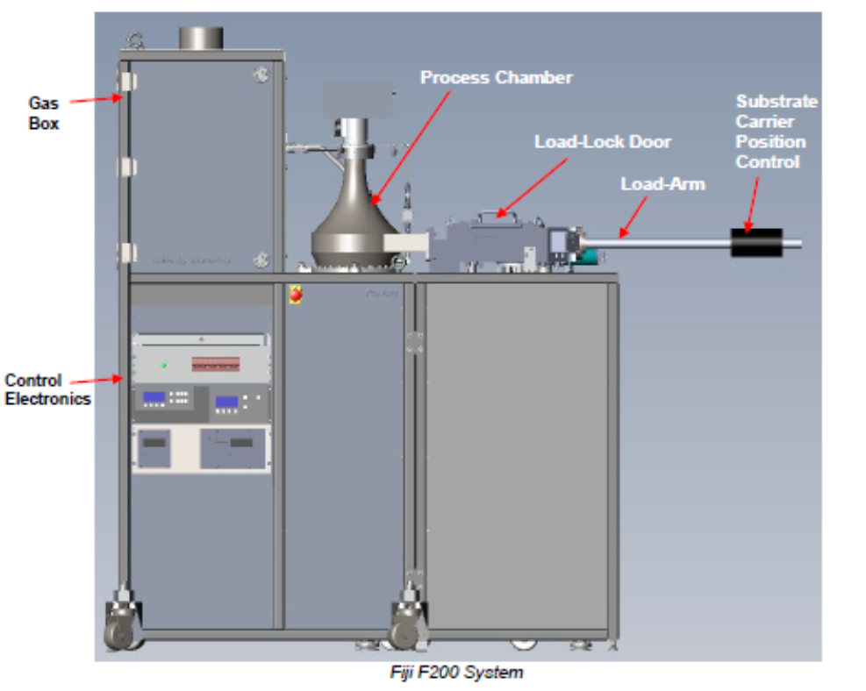
The Cambridge FIJI 200 ALD system is equipped with a sample load lock and transfer arm. These components are visible and accessible in the user side of the cleanroom bay. The remaining portion of the system is behind the bay wall in the cleanroom chase and is not accessible by NRF users.

CAUTION  CAUTION

Users are not to access components located in the cleanroom chase. This violates NRF policy, and the user will be removed from the cleanroom.

- User Interface Overview
The Cambridge ALD tool in controlled through a software interface. All operation of the system except for sample transfer is performed via this software interface. Figure 1 shows the software screen shot and indicates important system fields. These fields will be referred to in this manual and during processing. This is an image of the PROCESS tab screen. Though this screen, recipes will be loaded and run and system status can be verified.
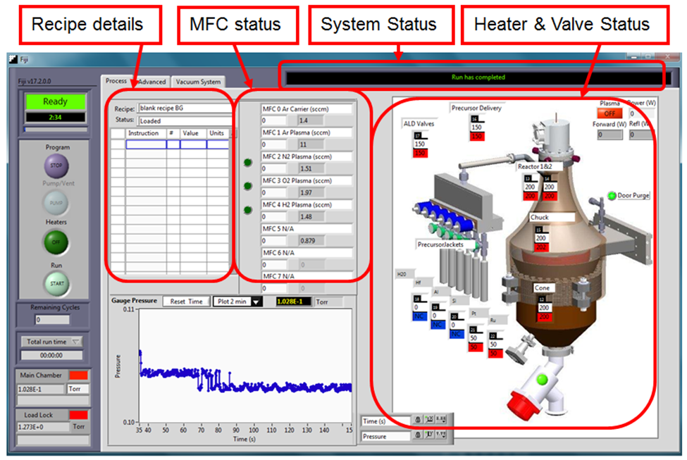
Figure 1. Software screen shot, PROCESS tab.

Heater idle temperatures are as follows and should remain at these levels for idle.

ALD Valves (#17) ………………………… 150°C
Precursor delivery (#16) ……………140-150°C
Reactor 1&2 (#13, #14) ……………...195-200°C
Chuck (#15) ……………..………………………200°C
Cone (#12) ……………………………….….…..195-200°C

All precursor jackets should be at 0°C for idle. “NC” indicates no heater jacket is connected for that precursor.

The tab VACUUM SYSTEM (figure 2) shows the status of the valves on the Cambridge FIJI 200 and their position. A bright green indicator indicates the valve is open. Also on this screen are the Vacuum and System Sequence fields where the operator can find the [Vent] and [Transfer Sample] buttons to start the load/unload procedure.

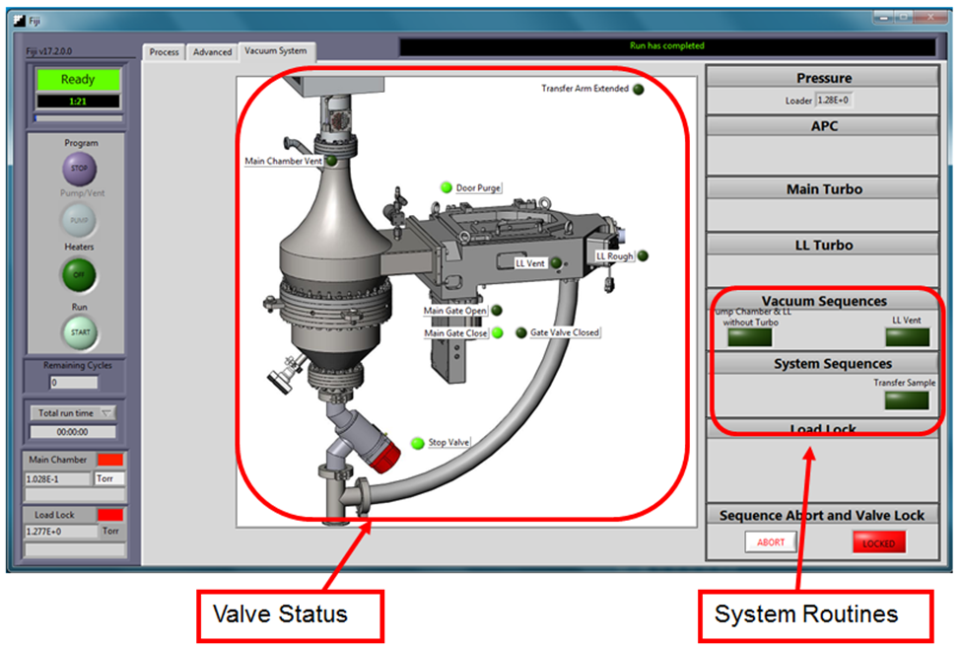
Figure 2. Software screen shot, VACUUM SYSTEM tab.

There is a third tab in OPERATOR MODE labeled ADVANCED. Users are to avoid changing settings in this tab. These are critical system parameters and changes made to this tab are reserved from NRF staff.

CAUTION CAUTION
Users are not to alter settings in the ADVANCED tab. Access to this tool
will be revoked if the user is discovered altering these settings.

- Operation
The system should be running, and the software should be displayed on the monitor. Check the system vacuum pressure and the status of the heaters. Chamber vacuum levels are read at the lower left of the program screen. A typical process chamber pressure will be in the 2.5 to 8.5 E-2 Torr range.

NOTE: prior to using the ALD system, you must manually take the tool out of the idle state as described below.

Reduce the flow on MFC #0 (Ar Carrier) to 0 sccm. Reduce the flow on MFC #2 (N2 Plasma) to 0 sccm and close the N2 valve for MFC #2.

NOTE: for all sample loading instructions, all rotation positions of the transfer arm magnet are with respect to the top of the transfer arm.

  - Sample loading
    - Have sample prepared and ready to load. The bare wafer holder is designed to hold an 8” wafer or small pieces. Use small supplied washers to pin small substrates down.

    - Ensure the main gate valve is in the closed position. On the VACUUM SYSTEM tab, the Main Gate Closed indicator should be bright green.
    - Ensure the transfer arm is fully retracted. The Transfer Arm Extended indicator should be dark.
    - Vent the load/lock chamber by toggling the [VENT] button in the Vacuum Sequence field on the VACUUM SYSTEM tab. A notice will appear stating the system is venting (it is referring to the load lock). Wait a few minutes for the load-lock to vent to the atmosphere. You can check the status of the load lock by attempting to open the door. Once the door opens, click [OK] button in the dialog box.
    - Once vented, open the load lock chamber door and load the sample onto the wafer holder. Close load lock door when finished.
    - Click the [Transfer Sample] button on the VACUUM SYSTEM page in the System Sequences field. This will start the transfer routine. The System Status should progress through the following notices:

- Load/Unload Sample…waiting for main chamber to pump out
- Load/Unload Sample…Equalizing chamber pressures
- Please load or unload sample
(the main gate valve opens, and a user response box appears)

NOTE: if the loadlock and main chamber pressure fail to equalize, an error notice will appear. Click [OK]. The program will appear to continue with the loading routine; however the main gate valve will not open. This is a program error. Ignore the notice to transfer sample and click [OK]. DO NOT ATTEMPT TO LOAD SAMPLE, MAIN GATE VALVE IS CLOSED. Wait for the system to reset and return to step f., this time the sequence should execute fully.

Wafer holder
Effector
Transfer arm

Figure 3. Illustration of wafer holder and effector (end of transfer arm)

LoadLock
Extended microswitch
Transfer Arm Magnet
Position Stop
Main Gate Valve
Rotation angle indicator

Figure 4. Illustration of transfer arm and components

TOWARD

AWAY

Figure 5. End view illustration of Transfer Arm Magnet indicating rotation directions.
CAUTION CAUTION

DO NOT IMPACT THE WAFER HOLDER INTO
THE MAIN GATE VALVE!

    - The following steps must be followed exactly to successfully load the sample holder. Refer to figures 3-5 if needed.

- Rotate the transfer arm magnet toward you to 250°. This raises the wafer holder to its upper position.
- Slowly move the transfer arm into the process chamber until the transfer arm magnet comes into contact with the position stop.
- Rotate the transfer arm magnet slowly away from you to 325°. Please note that the default position of the transfer arm is about 320°. This could change over time with usage. Users are requested to report a change in position if they notice this change. This lowers the sample holder onto the chuck.
- Slowly and firmly withdraw the transfer arm, it will move freely once the wafer holder is disengaged from the effector.
- Rotate the transfer arm magnet to 335°.
- Slowly, move the transfer arm back into the main chamber. The effector will contact the wafer holder (~2” from position stop). Push gently until the transfer arm magnet stops (~1 inch from position stop). At this position, the transfer arm magnet will not travel further into the chamber.
- Slowly remove the transfer arm fully so the Transfer Arm Extended indicator is dark.

    - Press [OK] when finished on the user response box. This will close the Main Gate Valve.
NOTE: The Main Gate Valve will not close unless the Transfer Arm Extended indicator is dark, the arm must be fully retracted and engaging the micro switch.

  - Loading recipe and running processes
As an operator, you will only be able to load, modify and run recipes. Modifications to recipes are not saved to the permanent recipe file and are only executed for your run. Any permanent changes to a recipe will have to be performed by NRF staff. Please be sure to provide sufficient time prior to your reservation for staff to create/edit the recipe for you.
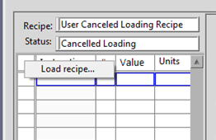
    - Right click on the upper left corner of the recipe field.
This will open a menu, select LOAD RECIPE.
Then browse and select the recipe you wish to run.

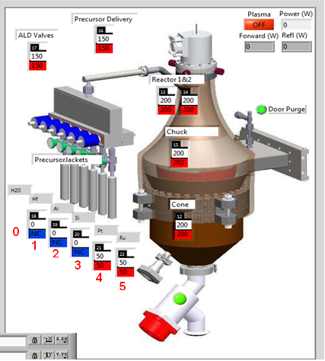
    - You must change the pulse port in the recipe from the element formula to a numerical value. This value must correspond accurately to the correct pulse port number otherwise the wrong material will be deposited. On the main Process Screen, the pulse ports are shown and the materials loaded are displayed. Water (H2O) is always on pulse port #0. The remaining pulse ports are #1 though #5. The pulse ports are activated by the “pulse” line in the recipe.

    - If your recipe requires a heated precursor, you must also ensure that the correct heater jacket number is listed in the recipe. The heater jacket numbers are listed in the Process Screen, and these are in the recipe as “heater” and “stabilize” in the recipe lines. A list of precursors and jacket temperatures are listed below. The jacket heaters are #18, #19, #20, #21, #22. A “NC” under a precursor indicates no heater jacket is connected.

DO NOT change the temperature of heaters #12, #13, #14, #15, #16, #17 in the recipe.

Hafnium (Hf) – 80-90°C, (95°C for exposure mode)
Platinum (Pt) – 70 to 75°C
Ruthenium (Ru) – 110°C
Titanium (Ti) – 75 to 80°C
Zirconium (Zr) – 85°C (Thermal mode)

    - The idle temperature for all heated precursors is 0°C. The precursor heater jackets should be at 0°C when you log in and when your runs are completed. The user can change the number of cycles. This change will not be saved to the permanent recipe file. Remember the number of cycles and report it as “comments” on the TUMI system while logging off. Failure to do so will result in the group being billed inaccurately. The default values are high.
Please DO NOT set the number of cycles to 0 as this will cause the program to run an infinite loop.
All recipes will be modified to reset the process chamber temperatures back to the idle temperatures listed in section 5.0. This is to reduce the occurrence of users forgetting to reset the temperatures at the end of their run.

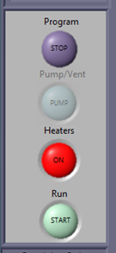
    - To start the recipe, click on the [START] button under
Run on the left menu (bottom button). This prompts
the system to check all interlocks and run the recipe.

Click YES in the user response box that appears.

The recipe will auto execute. There may be a delay if
the chuck temperature (15) or chamber temperatures
in the recipe are different from the idle temperature.
Once the temperature is stabilized, the recipe will run.

The recipe can be monitored by watching the PROCESS tab, recipe details and the Pressure Status of the system. Each valve operation will result in a pressure change that can be noticed in the pressure graph.

Do not use the Program STOP button to abort a recipe, this button will turn off the ALD program and ramp down all heaters. NRF staff must reset the system to enable the software once the program is stopped.

WARNING: The button under the heaters section MUST NOT be RED when you start the recipe. TOGGLE it to GREEN if it is not already so. Make sure the heater jackets are set to the right temperature. CONTACT NRF STAFF IMMEDIATELY.

CAUTION CAUTION

THE USE OF THE PROGRAM STOP BUTTON RESULTS IN
THE HEATERS LOSING POWER. REACTIVATION OF THE
SYSTEM REQUIRES NRF STAFF.

NOTE: Once the recipe starts, keep an eye on the “Remaining Cycles” tab. If it is different than the number entered, ABORT AND CONTACT NRF STAFF IMMEDIATELY.

NOTE: Changing the number of cycles after the program has started running will not change the initial settings.

  - Sample unloading
Once the recipe is finished and the chamber is pumped down into the 3.0E-2 Torr range, the sample holder can be removed.

NOTE: for all sample loading instructions, all rotation positions of the transfer arm magnet are with respect to the top of the transfer arm.

    - Click the [Transfer Sample] button on the VACUUM SYSTEM page in the System Sequences field. This will start the transfer routine. The System Status should progress through the following notices:
    - Load/Unload Sample…waiting for main chamber to pump out
    - Load/Unload Sample…Equalizing chamber pressures
    - Please load or unload sample
(the main gate valve opens, and a user response box appears)

CAUTION CAUTION

DO NOT IMPACT THE WAFER HOLDER INTO
THE MAIN GATE VALVE!

    - The following steps must be followed exactly to successfully unload the sample holder. Refer to figures 3-5 if needed.

- -Rotate the transfer arm magnet away from you to 330°. This places the effector just below the engagement position on the wafer holder.
- -Slowly move the transfer arm into the chamber until the effector comes into contact with the wafer holder.
- -While applying slight forward pressure on the transfer arm magnet, rotate the transfer arm magnet slowly toward you to raise the effector. Stop the rotation of the transfer arm magnet once the transfer arm slides forward, about 305°. This is the engagement position for the effector into the wafer holder.
- -Without rotating the transfer arm magnet, slowly and firmly push to engage the effector into the wafer holder. Once the effector is fully engaged, the transfer arm magnet will touch the stop on the transfer arm.
- -Rotate the transfer arm magnet towards you to 250°, this raises the wafer holder off the chuck.
- -Slowly remove the transfer arm and fully retract it so the Transfer Arm Extended indicator is dark. The sample holder should be visible in the load lock window.

    - Press [OK] when finished on the user response box. This will close the Main Gate Valve. Once the sample transfer is complete, the Door Purge valve may open. Close this valve by toggling the Door Purge indicator from bright green to dark. This will conserve N2 use.

NOTE: The Main Gate Valve will not close unless the Transfer Arm Extended indicator is dark, the arm must be fully retracted and engaging the microswitch.

    - Vent the load/lock chamber by toggling the [Vent] button in the Vacuum Sequence field on the VACUUM SYSTEM tab. A notice will appear stating the system is venting (it is referring to the loadlock). Wait a few minutes for the loadlock to vent to atmosphere. You can check the status of the loadlock by attempting to open the door. Once the door will open, click [OK] button in the dialog box.
    - Once vented, open the load lock chamber door and unload the sample off of the sample holder. Use caution, the sample and sample holder will be very hot. Close sample door when finished.

CAUTION  CAUTION

THE SAMPLE AND WAFER HOLDER WILL BE VERY HOT (OVER 100°C).
USE CAUTION TO NOT TOUCH THE WAFER HOLDER OR SAMPLE RING.
LET THESE COOL COMPLETELY PRIOR TO REMOVAL.

CAUTION 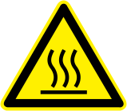 CAUTION
  - Standby Mode
If any changes were made to the Chuck temperature, please reset to the idle temperature of 200°C. You must also reset the precursor jacket temperature(s) to 0°C.

    - Pump the load/lock back under vacuum.
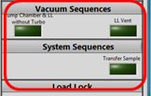
On the Vacuum Sequences area Press Pump Chamber & LL without Turbo. Wait for sequence to complete.

    - Load the “blank recipe” – this will blank out the recipe screen and return any user edited recipe to its default values
    - Set the ALD system in its idle state
Set the flow of MFC #0 to 5 sccm.
Open the N2 valve for MFC #2. (Click green button next to MFC#2)
Set the flow of MFC #2 to 10sccm.

This will place the ALD is an idle state allowing a small portion of gas to flow into the chamber and through the valve manifold. This helps maintain a clean valve manifold and reduce the chance of cross contamination.

Do not close the ALD program. Do not press the Program STOP button, this will turn off all the system heaters and will require NRF staff to reset the tool (a hardware reset is required on a non-user accessible component).

CAUTION CAUTION

THE USE OF THE PROGRAM STOP BUTTON RESULTS IN
THE HEATERS LOSING POWER. REACTIVATION OF THE
SYSTEM REQUIRES NRF STAFF.

Log off the ALD system in the TUMI computer and leave the appropriate notations.

NOTE: In the TUMI logoff notes, indicate the type of ALD run (conventional or exposure), the number of ALD cycles, and the source material used. For examples:

Conventional ALD, 278 cycles, Al
Or
Plasma ALD, 311 cycles, Hf

Failure to do so will result in limited access to the ALD system.

- Approximate Heating and cooling times for the ALD
Please be sure to add these heating and cooling times to your reservation to ensure enough time for the system to recover back to the idle temperature for the next user’s access.

Idle state 200°C chuck, 195-200°C chamber and cone to

Heating from 200°C to 300°C – 1.0 hrs
Heating from 200°C to 400°C – 1.0 hrs
Heating from 80°C to 200°C – 1.0 hrs

Cooling from 200°C to 80°C – 7.5hrs
Cooling from 300°C to 200°C –4.5hrs
Cooling from 400°C to 200°C – 5.0hrs

- Software and Tool glitches.
Below are some known issues with software and tool you may encounter during operation.

    - Failing to replace precursor name with valve number on the “go to” part of the recipe will default to pulsing water instead of your precursor.

    - During sample transfer routine, software can hang up on “waiting for chambers to equalize”. Do not leave the system on this state. Press abort on bottom right of the page and initialize sample transfer routine again. This will go through a second pump cycle and most likely will resolve the issue. If your sample outgases, you will encounter this issue during a transfer sample. Please contact staff if you have any questions or can’t get pass this state.

    - Failure to set precursor temperature to proper temperature will result on under or no pulses during your run.

Please record below other issues you encounter with the tool.

- FAQs and Tips for ALD
What valve temperature should I use?
The valves on the system (Swagelok pneumatic ALD valves) we recommend the following: Swagelok valves can be heated up to 200 °C. We recommend the Swagelok valves be heated to 150°C for non-heated precursors (water, TMA etc). Please ask Cambridge NanoTech Inc. for settings for your conditions before trying anything at random.

What is the dose that I should use for the precursors?
We recommend asking Cambridge NanoTech Inc. for a recipe before any run since there are many parameters interconnected (substrate material, precursor, temperature, purge time etc.), that one general recipe cannot be mentioned. One general guideline is that the precursor pulse height should be about 1 Torr or less. For TMA and other high vapor pressure materials, one should not pulse for more than about 0.02 seconds, unless Cambridge NanoTech advises otherwise. This is to prevent premature contamination of the system. Also, high vapor pressure materials should not be heated and the heating jacket should be removed to prevent the cylinder from getting hot from the valve heating block above it.

Why is there nitrogen flow and what is the recommended setting?
Nitrogen (or argon) flow is used for various reasons. The first reason is to quickly purge the system between each pulse. It is important that between the precursor pulses, there is no residue (except for the monolayer chemically bonded to the substrate) of precursor in the process chamber. The presence of two precursors at the same time would cause immediate reaction in vapor phase, which can lead to CVD mode deposition (non-uniformity, thick coating, powder formation). So, the combination of temperature, nitrogen flow and pump time between pulses prevents two precursors from seeing each other in vapor phase. At low process chamber temperatures (e.g. 100 °C), the pump time needs to be higher (e.g. 30 sec) than at high temperatures (>150 °C, pump time e.g. 8 sec, for TMA). The higher the temperature, thus the faster the cycles. Another reason for nitrogen flow is to prevent flow of precursor from one pulse valve into the other. It is important that the pulse valves only see their own precursor, thus each valve has a constant nitrogen flow. The constant nitrogen flow out of each valve prevents other precursors to enter, and thus prevents deposition in each valve. A recommended nitrogen flow value is 20 sccm. During venting this is increased to 100 sccm, and also while the process chamber is open, this should be the maximum flow value (100 sccm) to prevent air from entering the valve regions. One should immediately close the lid door inserting/removing a substrate and not leave it open.

What is the expo for, should I use it?
Expo deposition means that prior to pulsing a precursor, the main vacuum valve (valve between process chamber and pump) is closed, then one precursor is injected, then the substrate gets exposed during the expo time (for example if expo = 20 seconds, the main vacuum valve opens after 20 seconds). This mode is only used when one needs to coat very high aspect ratio structures (>1:10). The disadvantage of using expo runs is that since the precursor does not simply flow very fast from cylinder through valve through manifold over substrate into pump, instead, it sits in the process chamber for expo seconds, and some of the precursor can migrate to all valves. This can cause some deposition in the valves, especially if the expo time is long. To reduce this effect, one could pulse two times in expo mode (for very high aspect ratio structures) to prevent the process chamber pressure from getting too high during the expo time. If one wants to get better nucleation on hydrophobic substrates, we don’t recommend expo mode deposition. Instead, one could pulse two times the same precursor in multi dosing deposition mode (expo=0 seconds), and this would only be needed for say the first few cycles. This may be especially useful for thin gate dielectrics.

Atomic Layer Deposition: Principle of Al2O3 formation

Atomic Layer Deposition (ALD) is a technique that allows growth of thin films, atomic layer by layer. The typical ALD reaction is illustrated via the formation of Al2O3 from trimethylaluminum or TMA, Al(CH3)3, and water, H2O. Recipes for other materials can be found in the literature.

Step 1: Introduction and adsorption of precursor A to the surface.
The precursor, trimethylaluminum, reacts with hydroxyl groups on the surface of the substrate, liberating methane. The reaction is self-limiting as the precursor does not react with adsorbed aluminum species.

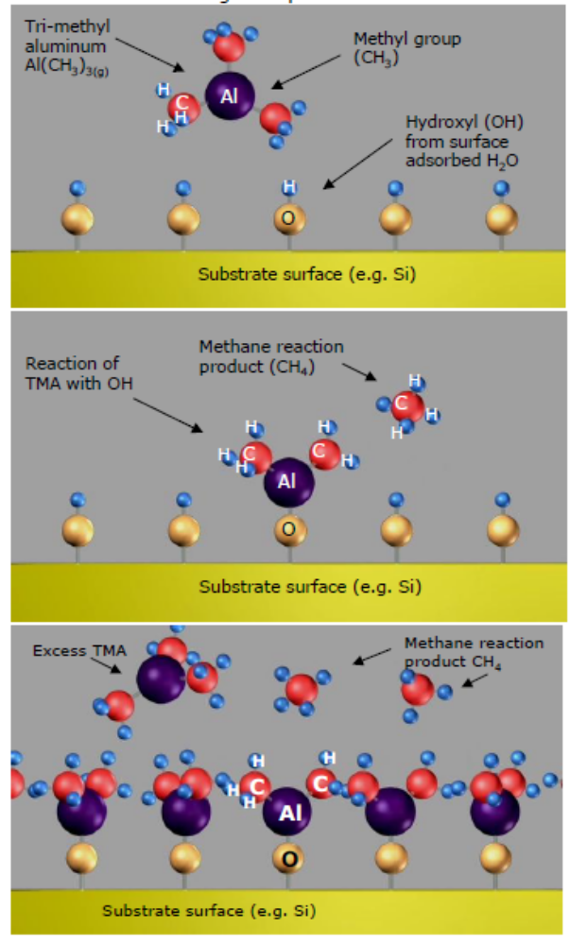

Step 2: Removal of the unreacted precursor and reaction products.
Unreacted precursor and the methane (CH4) liberated from the reaction are removed by simple evacuation of the sample chamber or by flowing inert gas over the surface.

Step 3: Introduction and adsorption of precursor B to the surface.
Water reacts with the methyl groups on the deposited aluminum atoms forming both Al-O-Al bridges, as well as new hydroxyl groups. The formation of hydroxyl groups readies the surface for the acceptance of the next layer of aluminum atoms. Methane is liberated as a by-product

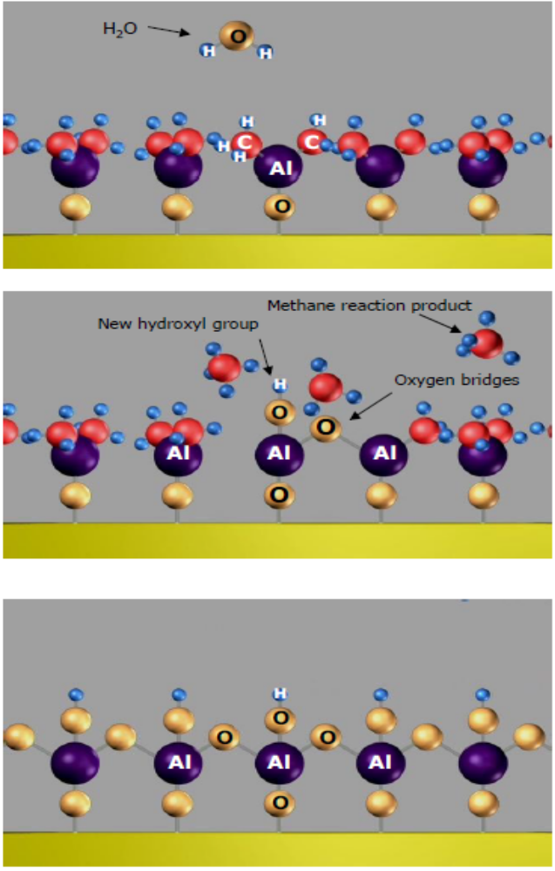

Step 4: Removal of the unreacted precursor and reaction products via evacuation and/or inert gas flow.

Step 5: Repeat to create layers

The process begins again with the introduction of precursor A followed by B. Atomic layers are built up one after the other.

- Recipe Example Al2O3 Thermal Mode.

Below is an example of an Al2O3 recipe for the Cambridge Fiji system

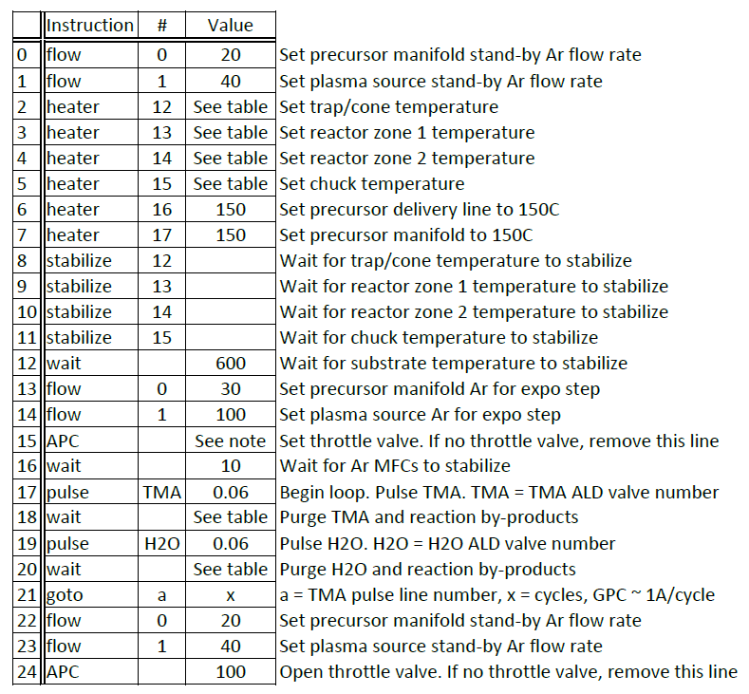

Part | item |  | Price/pulse
 |  |  | assume 4mg/pulse
Al
98-4003 | TriMethylAluminum (TMA) |  | $0.16
Ti
98-4015 | Tetrakis(dimethylamido)titanium(IV) |  | $0.24
Ru
98-4009 | Bis(ethylcyclopentadienyl)ruthenium(II) |  | $1.16
Pt
98-4024 | Trimethyl(methylcyclopentadienyl)platinum(IV) |  | $1.16
Hf
98-4021 | Tetrakis(dimethylamido)hafnium(IV) |  | $0.30
Si
98-4035 | Tris(dimethylamino)silane, 99+% |  | $0.21
Zr | Tetrakis(dimethylamino)zirconium(IV) |  | $0.29
98-4012
- Precursor Surcharge Table.

