
Panalytical XPert Powder XRD
  - Standard Operating Procedure (SOP)

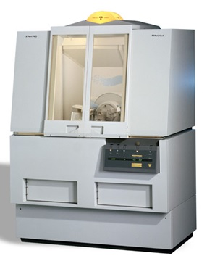

  - Application
X-ray crystallography is a technique in crystallography in which the pattern produced by the diffraction of x-rays through the closely spaced lattice of atoms in a crystal is recorded and then analyzed to reveal the nature of that lattice. The MPD is for polycrystalline samples, this machine is not for the analysis of thin films, and samples on a single crystal substrate may not be analyzed with the MPD. Films and samples on a single crystal substrate should be analyzed with the MRD.

Contents
Safety 3
Training 3
Logging In 3
Sample Preparation 3
Options for Sample Prep: 3
Preparing Samples with Round holders: 4
Bracket stage options for sample prep: 4
Using the Software: 5
General Scan Recommendations: 8
You have Data… Now What? 9

Safety
High Voltage This machine uses high voltages, especially to generate the X-ray beam. Do not touch any parts of the machine aside from those specifically mentioned in this SOP.

X-rays X-rays are a very harmful form of radiation and care should be taken to minimize exposure. Never attempt to break a tool safety interlock.

Moving Components This machine has heavy moving parts. Although these parts only move inside the machine while the X-ray is on (and thus should be out of the user’s path), care should be taken to ensure you do not get in the way of a moving part.

Training
Training for this machine is scheduled on demand. Please use the RSC website to request training if you would like to use the machine.

Logging In
Before you begin your session, you will need to log in to the TUMI laptop on the sample prep bench. It is not necessary to log in before changing the stage (if you need to do so). If the computer will not wake, double check that you have successfully logged in. The Powder XRD tool at the TUMI should say “IN USE” if you are logged in completely.

Sample Preparation
This tool should only be used to measure polycrystalline materials. Samples MAY NOT be run if they are on a wafer substrate without staff supervision. Scanning a single crystal peak will damage the detector, your PI/advisor will be charged for the repair or replacement.

Options for Sample Prep:
We have 2 sample stages, and a variety of options for sample prep. The round sample stage is the default stage that should be in place at the start/end of each session. If you prefer the bracket stage, simply change the stage (unscrew the 3 screws on the round stage bracket, pull off the stage with an up and out motion careful to not bang the source/detector optics, and install the bracket stage and 4 screws on the mount). There is NO NEED to tell the software you made the change, it is unnecessary and just gives the tool an excuse to be difficult.

Sample height is very important, noticeable peak shift can occur with height errors of 100um or less. With each technique be sure you know what height the sample *should* be and ask for assistance if you are unsure.

Preparing Samples with Round holders:
The ring holders have a variety of options:
Packed powder rings for samples that have sufficient volume to fill these. They are backfilled to reduce orientation issues. The JIAM diffraction lab (collaboration of UT and ORNL) have posted many videos on YouTube demonstrating preparing samples and XRD concepts in general, if you prefer a more visual learning experience.

Zero Background Holders: These work best when you need to recover your sample, want to maximize your signal to noise ratio, and don’t have enough material to fill a packed powder holder. You may install the zero-background plate into the ring and sprinkle some material into the central depression, then height check the sample. Note: these holders are stored in the box with the aluminum plate in to prevent damage to the ZB plates. Don’t use the aluminum plate during scanning.

Bulk sample holders: If you have a bulk solid, and want to scan this, the round bulk holders are usually best. You will need the sample to be thinner than the holder, and as smooth as possible on the exposed surface. You will use a SMALL amount of modeling clay to support the sample, then flatten the sample to the ring height with a long glass slide. I don’t have a video for this but am happy to demo this upon request.

If you have films, or samples for transmission XRD please contact staff.

Bracket stage options for sample prep:
Aluminum backfill: These require a large amount of material, but offer the most robust scans, and meet the constant volume assumption for advanced refinement techniques. These holders can give you the overall best quality data for most samples… if you have enough to fill the holder. If you expect to have large quantities of powder to scan we can walk through the steps during your training, for a refresher you can search for the visual guide in the USGS Open-File Report 01-041: XRD sample prep methods.

The glass slide technique: For years students have used double-sided tape to secure their sample in place, and scotch tape to height match for loading. This technique is the most likely technique to give a high background signal, increased chance of orientation effects, and can easily have height matching issues. I don’t recommend using this method unless you have no other choice. If you choose this method anyway, you can find glass slide guides in the sample prep toolkit showing where on a slide to place your double-sided tape for sample dusting, and where to place the scotch tape for height matching.

**If none of these techniques seem applicable to your sample, please ask for suggestions. We have come up with a few other creative solutions in the past, but they are not considered “standard” sample prep, and thus not included here.

Glass slides and other sample prep tools can be cleaned and reused. If glass slides are damaged or should not be reused for any other reason (contact with hazardous material, etc) they should be disposed of in the cardboard box. NO SAMPLES should go in this box, only “clean slides”. Remove sample from the slide and dispose of it in the hazardous waste bin or trash as needed. Absolutely no glass slides in the Hazardous waste bucket.

IPA is available in the lab for cleaning, acetone and other solvents can usually be found in the hood in lab 222 across the hall if needed. Tap water is also sufficient for final rinsing of the aluminum or glass materials used. Currently the DI water tap in 233 is off.

Please message staff if supplies run out, are missing or damaged, or waste containers are filled. You can email us directly, text the XRD specific staff, or leave a comment when you log off the TUMI computer (be sure to select email message to staff or we will NOT see it).

Using the Software:
Usually, the software will remain open. If it is not (computer restart, or previous user closed it) you will need to:
- Open the Data collector program: username and password are on the front of the SOP binder.
- Select the Instrument drop down menu, select connect
- Select the Transmission/Spinner stage (even if using the bracket stage, always select the spinner stage).
- A warning looking pop-up opens, select OK.

If the software was already open, you will begin here

On the left panel you will find the instrument settings
Under X-ray double click any option to open the x-ray control window.

Raise the current to 40mA, type 40 in the current box and select OK. Listen for any popping sounds, if you hear any contact staff (this is extremely rare). Leave the current at 45kV, it should never be changed. The current should never be raised above 40mA.
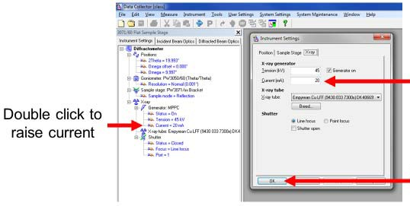
45-20 is standby conditions, 45-40 is scanning conditions. If you find the tool in any other state please contact staff before using.

If you are using the round stage, make note of the Lift option under sample stage on the left panel. The lift controls the stage opening and closing. Double click this, and then uncheck the box and select apply to lower the stage for sample loading. Check the box, and select OK to raise the sample into scanning position. Attempting to run any scan with Lift=Down will result in bad data.

The detector moves when loading samples for the round stage. If your scans need to begin below ~10 degrees 2-theta I recommend resetting the offset before trying to run the program. Double click position, and change the omega offset to 0, and select ok, this should return the machine to a symmetric setup and prevent issues with low start angles on your scans. Clicking the blue P in the top control bar should have the same effect.

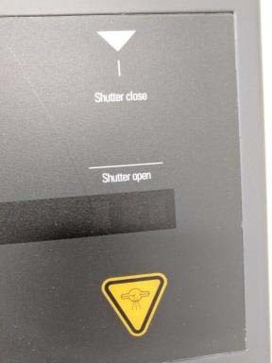
NOTE: The tool has a shutter indicator on the front panel. NEVER attempt to open the doors while parts are moving, this will result in an error message. If the machine is unsafe to enter due to active x-rays, the doors will be locked and the indicator below will be shown.
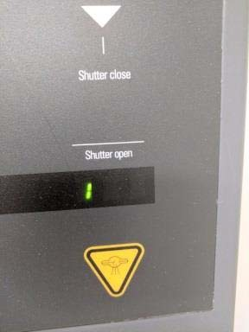
No 1: Safe to open, no active x-rays 1 visible: Not safe, active x-rays

Do not attempt to open doors if the lock is engaged. No significant force should be applied to the doors at any time, when safe the doors should open easily.

To edit a program, select File> Open Program
Select the program matching the stage you are using. The round stage has 2 options, spin ON, and NO Spin. Spinning will not hurt anything, but 90% of the time is unnecessary. If you have a very small sample volume spinning MAY help boost signal.
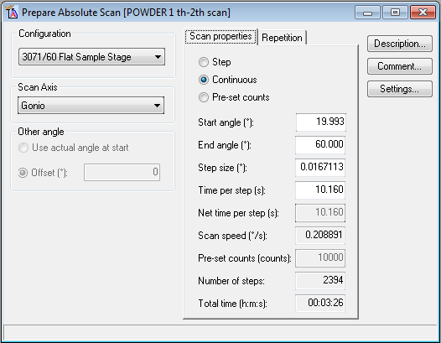
You only need to modify the 4 white boxes. And follow these rules
Start angle should NEVER be less than 5 degrees. This is likely to damage my detector, and your end angle must be less than 154, the software won’t let you enter something outside this range.
Step size is up to you, 0.008 is usually considered publication quality, 0.016 is “good enough for government work”, and 0.002 is the smallest step our machine can take.
Time per step is your choice, it affects the quality of your scan, and the time you sacrifice at the tool. Counting longer will typically improve signal to noise ratio.

General Scan Recommendations:
Time per step, I usually tell people to start with a value between 10 and 20 and make adjustments from there if needed.
Major peaks should be over 1000 counts for phase ID, and approaching or over 10,000 counts for structure refinements (these are counts not dwell time per step). Time needed to achieve this will vary greatly from one material to another (total mass used, and actual composition play a factor).
When in doubt, I use a 0.016 step size, or 0.033 is a good survey step size.
Reasonable major phase ID scans should require 10-15 minutes of scan time (for large 2-theta ranges), detection of minor phases and refinement quality scans will likely require 30-minutes to an hour, and structure refinements generally require even longer scans. Of course these are suggestions and not requirements, your project needs may vary.

The software has no save button, you can File>save (do not “save as” or change the file name), or you can close the window and select yes when asked if you want to save the program.
To run the program, select the Measure> Program option. NEVER choose manual scan, it doesn’t do what you’d think it does and is only used for alignments by the service engineers.
Select the program you just saved, and then in the pop up enter your file info. Scan files always default to the XRD data folder. You may navigate to your folder for each scan file, or save them all in XRD Data and move them later.

The scan will begin when you hit OK on this window, be sure the doors are closed before you select OK.

If you need to pause/cancel a scan use the red stop sign in the tool bar in the software.
If the graph X-axis is not updating, right click on the graph, select axes, and then select the auto rescale option.

You have Data… Now What?

Once you are ready to process your data, review the suggestions and video links in the Helpful Information folder on the XRD desktop for some basic information. Once you have a plan, I am more than happy to help, but you need to know the end goal and process you want to follow or we will be digging through tons of software options along the way.

The XRD scan data file format saved is a .XRDML file. This file is specific to Panalytical and cannot be opened in very many programs. I suggest converting your files to a more useful format.
You can highlight all your files, and then right click, and select “Convert”, or you can open your files in Data Viewer (double click the files to open data viewer) and then File>Convert or Convert All.
The default is set to convert files to text .xy files, a list of the x,y coordinates to replot your data in whatever program you choose. If you want a .csv you need to use the File>Convert in Data viewer (not Convert all) and change the file type to your desired format.
The NRF facility has 2 Data Processing programs available, and the ICDD Powder Diffraction Database available. On the XRD operating PC you can find Highscore plus inked with our perpetual 2016 ICDD database license (phase ID only). On the XRD workstation you will find this years current PDF database, and Jade software for phase ID, and quantitative analysis of your scan data.

For free tutorials on how to use the Jade software you can email mdi@materialsdata.com to request the monthly password to their webinar videos. Most people find these very comprehensive and helpful.

Included in your XRD training is an expected ~15-30 minute software tutorial. It rarely makes sense to cover this at your introductory training session. We recommend collecting some data, reviewing with your team what is needed, watching a tutorial or two from MDI and then requesting time with staff to review your process if needed. There is of course no obligation to use our software or workstation for processing.

At your training we will open HighScore and look at the quick phase ID process. The youtube channel for JIAM previously mentioned above also has some Highscore tutorials if you are interested in seeing more of that software. Remember, our HighScore version cannot be used for refinements or quantitative work, phase ID only.

